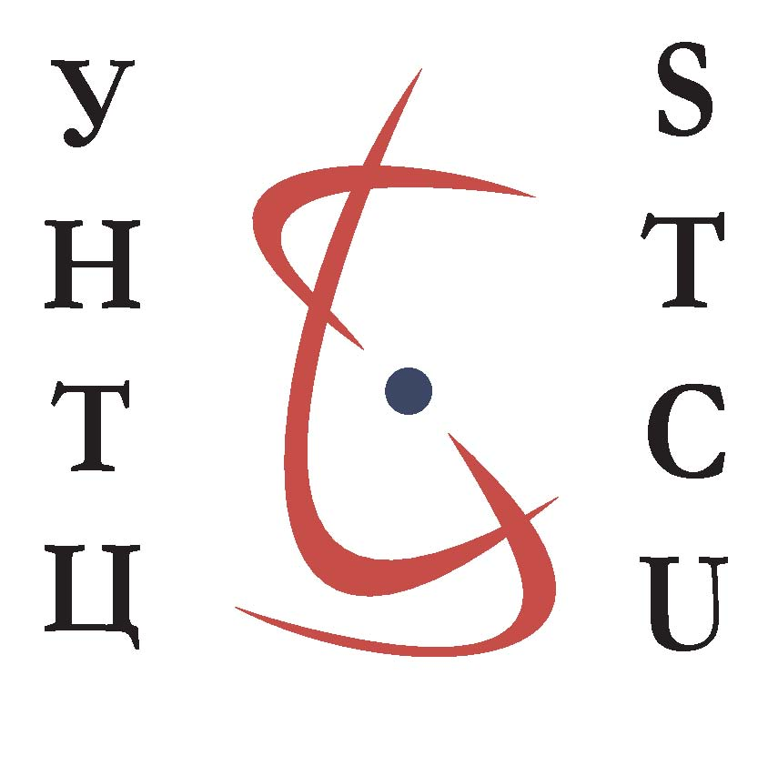 | Thematic International Conference on  Bio-, Nano- and Space Technologies,  E U & Science Centers Collaboration  Ljubljana, Slovenia March 10-12, 2008
 |  | (Draft version, 30-Jul-26)

First day: Grand Opening MARCH 10, 2008

LOCATION: Institute Jozef Stefan

09:20-09:30 (10 min.) Opening Words

Chairman of the Opening Session, Mr. Zoran Stančič, Deputy Director General, Directorate General for Research, European Commission, Chairman of the Governing Board of the STCU and Board Member of the ISTC.

09:30-11:15 (15 min. each) Welcome Speeches

High representative from Slovenian Government,
Mrs. Mojca Dolinar Kucler (TBC)
Minister of Higher Education, Science and Technology, Republic of Slovenia
And/or State Secretary Mr. Dušan Lesjak (TBC)

High representative from European Commission,
Mr. Janez Potočnik
Commissioner for Science and Research, European Union

Mr. Jadran Lenarčič, Director of Institute Jožef Stefan

Mr. Boštjan Žekš, President of Slovenian Academy of Arts and Science

11:10-11:30 Coffee break

11:30-12:30 (30 min. each) Presentations

Mr. Andrew Hood, Executive Director of the Science and Technology Center in Ukraine, Kyiv

Mr. Waclaw Gudowski, Deputy Executive Director of the International Science and Technology Center, Moscow

The Press Conference will be held at the end of the morning of 10 March 2008 once the keynote speakers have addressed the participants.

12:30-13:30 Lunch

First day / Afternoon Session on Science Fields Presentations

The afternoon session is organized in a series of three sessions to present the current state of Scientific Research in Slovenia - the event Host Country – and then in the Member Countries of each of the Science Centers. Speakers may wish to include and introduce the thematic fields presented during the following two days: Tuesday 11th and Wednesday 12thof March.

13:30-14:30 (1h.) Session one : Slovenia Science Research Fields Overview

13:30 – 14:00 Mr. Franci Demšar, Director of Slovenian Research Agency

14:00 – 14:20 Mr. Blaž Golob, Slovenian Research Agency, EU Coordinator of the “Building and Improving Systems for Research and Technology Development” Project
14:20 – 14:30 Mr. Boris Cizelj, Head of the Slovenian Business and Research Organization, Brussels

14:30-15:45 Session Two : ISTC Science Research Fields Overview

14:30-14:50 Professor Academician Yuriy V. Gulyaev, Director of the Institute of Radio Engineering and Electronics, Russian Academy of Sciences (TBC ): Review of Russian research

14:50-15:10 Professor Academician Radik Martirosyan, President of National Academy of Sciences of Armenia, National Academy of Sciences of Armenia: Opportunities for Technical Innovation.

15:10-15:30 Academician Petr Vitiaz, Vice-President of the National Academy of Sciences of Belarus, Overview of Activities of the National Academy of Sciences

15:30-15:50 Dr. Natia Jokhadze , Director of the Georgian National Science Foundation, Review of Scientific Research in Georgia

16:05-17:05 Session Three : STCU Science Research Fields Overview

16:05-16:35 Joint Presentation by Vice-President of the National Academy of Science of Ukraine, Academician Anton Grigorievich Naumovets, Member of the National Academy of Science of Ukraine, and STCU Governing Board Member, Academician Yaroslav Stepanovich Yatskiv, Member of the National Academy of Science of Ukraine, Academician Yaroslav Borisovich Blume.

16:35 – 16:55 Doctor Academician Vagif Farzaliyev , Academy of Sciences of Azerbaijan, Presentation: “Overview of Science Research in Azerbaijan”.

16:55 – 17:05 Doctor Academician Ion Tighineanu, Vice-President, Academy of Sciences of the Republic of Moldova, Presentation: “Overview of Science Research in Moldova”.

17:05-17:45 (40m.) Analysis and Conclusion Session
“Strengths and Weaknesses of EU-Russia/CIS cooperation in S&T: Two Visions Deriving from ISTC Experience” Joint Conclusion Session” by Professor, Academician Jean-Pierre Contzen, European Union Science Advisory Committee Member, and Professor, Academician Evgueny Nikolaevich Avrorin, Russian Academy of Science, with an “Ukrainian Perspective” by Academician Anton Grigorievich Naumovets, Vice-President of the National Academy of Science of Ukraine

17:45-18:45 (1h.) Cocktail

Second day: Space Research Collaboration Conference MARCH 11, 2008

LOCATION: Institute Jozef Stefan, Ljubljana

09:00-09:15 (15 min.) Opening Words by Mr. Peter Volasko, Ministry of Science, Higher Education and Science, Responsible for International Cooperation (upon confirmation)

09:15-09:30 (15 min.) Opening Words by Academician Yaroslav Yatskiv, Head of the Aerospace Section of the National Academy of Science of Ukraine

09:30-09:45 (15 min.) Opening Words by Professor Yuriy V. Gulyaev, Director of Institute of Radioengineering and Electronics, Russian Academy of Science

09:45-10:05 (20 min.) Experiences with performed ISTC projects and expectations on future ISTC projects by Mr. Stephan Walther, Astrium EADS

10:05-10:20 (15 min.) ESTEC experience as ISTC collaborator in Russian contribution to EXPERT programme by Mr. Jean-Marie Muylaert, ESA ESTEC

10:20-10:35 (15 min.) ISTC Contribution to ESA "EXPERT" Project : Aero-thermodynamics altitude of capsule EXPERT by Mikhail Ivanov, ITAM, Russia

10:35-10:50 (15 min.) Testing Aerodynamics of Reentry Space Vehicles (EXPERT) with Simulation of Real-Flight Viscous Effects by Anatoly Kharitonov, ITAM, Russia

10:50-11:10 (20 min.) Coffee break

11:10-11:30 (20 min.) Reusable Multi-layer Thermal Protection System: Design, Manufacture and Test of the Mock-up by Dr. Victor Grigorievich Tykhyy, Yuzhnoye State Design Office, Dnipropetrovsk, Ukraine

11:30-11:50 (20 min.) Yuzhnoye Advanced Space Technologies by Dr. Alexander Pozniakov, Business Development Manager Europe, Yuzhnoye State Design Office, Dnipropetrovsk, Ukraine

11:50-12:10 (20 min.)

12:10-12:30 (20 min.) Space Transportation Assets Valorisation in Europe by Mr. Michel Pons, Centre Nationale d’Etudes Spatiales (CNES), Paris, France

12:30-12:45 Question and Answers

12:45-13:45 Lunch

13:45-14:05 (20 min.) The Role of the ESPI and Findings on Space Activities and their Future Development in Slovenia by Ms. Charlotte Mathieu, European Space Policy Institute, Vienna, Austria

14:05-14:25 (20 min.) Presentation by Mr. Guy Ramusat, European Space Agency (ESA), Paris

14:25-14:45 (20 min.) FP7 Space Work Programme and the 2008 Call for Proposals by Mr. Hartwig Bischoff, European Commission DG ENTERPRISE, Space Research Unit

14:45-15:05 (20 min.) Measurements of Earth Gravitational Field by Satellite Navigation Systems by Dr. Sergyi A. Matvienko, Yuzhnoye State Design Office, Dnipropetrovsk, Ukraine matvienko_2005@ukr.net

15:10-15:30 Coffee break

15:30-15:50 (20 min) DLR in Space, Aeronautics, Transport and Energy, Experiences in cooperation with ISTC, by Mr. Rainer Scharenberg, Corporate Development and External Relations, International Cooperation, Deutsches Zentrum für Luft- und Raumfahrt (DLR), Germany

16:00-16:20 (20 min.) Presentation of CNES-DLR-NKAU Twinning Project by Mr. Serguey Gerasimchuk, National Space Agency of Ukraine

16:20-16:40 (20 min.) New Technologies and Manned Mission to Mars by Dr. Vitaly F. Semenov, Keldysh Research Center, Russia, ISTC Projects #0092, #1171, #1172, #2120

16:40-17:00 (20 min.) Creation of high-effective solar power facilities on the base of rigidizable structures - step in the space solar power development by Dr. Olga Zaitseva, Lavochkin Association Russia, ISTC Projects #2835 and #2836

17:00-17:20 (20 min.) Questions and Answers, Joint Conclusion of the Session

- STCU Representative / Mr. Michel Zayet, Deputy Executive Director European Union
- ISTC Representative / Professor, Academician Waclaw Gudowski, ISTC Deputy Executive Director

Third Day: Life Sciences and Biotechnologies Session MARCH 12, 2008

LOCATION: Institute Jozef Stefan

09:00-09:15 (15 min.) Registration

09:15-09:35 (20 min.) Opening Words to be confirmed / by [Slovenian Section Chair ]

09:35-09:55 (20 min.) Presentation by Dr. Kristina Gruden , Head of Systems Biology Section, National Institute of Biology, Ljubljana

09:55-10:15 (20 min.) Russian Technology Platforms in Biotechnology and Food Research, by Dr. Vladimir Eryomin, Bakh Institute of Biochemistry Russian Academy of Sciences, National Contact Point FP7 Food, Moscow, Russia

10:15-10:35 (20 min.) Overview of computational biology in Ukraine: achievements and perspectives / by Mr. Dmytro Hovorun, Professor, Deputy Director, Institute of Molecular Biology and Genetics, National Academy of Sciences of Ukraine.

10:35-10:55 (20 min.) Structural Properties of Antimicrobial Peptides acting on Bacterial Membranes by Dr. Boštjan Japelj, Drug Discovery Department, LEK, Slovenia.

10:55-11:10 (15 min.) Coffee break

11:10-11:30 (20 min.) Title of presentation by Professor Damijan Miklavcic, Head of the Department for BioMedical Engineering, University of Ljubljana, Faculty of Electrical Engineering damijan.miklavcic@fe.uni-lj.si

11:30-11:50 (20 min.) Overview of Bakh Institute of Biochemistry, by Dr. Vladimir Eryomin, Bakh Institute of Biochemistry Russian Academy of Sciences, National Contact Point FP7 Food, Moscow, Russia

11:50-12:10 (20 min.) Novel aspects in plant microtubule pharmacology: molecular effects of antimitotic drugs seen with tubulin eyes by Academician and Professor Yaroslav Blume, Acting Director, Institute of Cell Biology and Genetic Engineering, Kiev, Ukraine
E-mail: cellbio@cellbio.freenet.viaduk.net

12:10-12:30 (20 min.) Safety/Risk Assessment of GMOs, using GM Crops as an Example, by Dr. Wendy Craig PhD, Biosafety Unit, International Centre for Genetic Engineering and Biotechnology (ICGEB), Trieste, Italy, e-mail: Wendy.Craig@icgeb.org

12:30-12:45 Question and Answers

12:45-13:45 Lunch

13:45-14:05 (20 min.) Title of presentation by Professor Dr. Peter Raspor (TBC), DDr.H.C. Head of Chair of Biotechnology, Biotechnical Faculty, University of Ljubljana, Ljubljana, email: peter.raspor@bf.uni-lj.si

14:05-14:25 (20 min.) Biological Microchips in Diagnostics of Drug-resistant Forms of Tuberculosis by Professor Almaz Aldashev, National Academy of Sciences of Kyrgyz Republic

14:25-14:45 (20 min.) Development of Effective Antiviral Agents of a New Type, by Dr. Oleg Iosifovich Shadyro, Belarus State University

14:45-15:05 (20 min.) Silicon-based Minerals for Ecological Agriculture by Mrs. Nataliia Zaimenko, Dr. Sc, Director National Botanical Garden, National Academy of Sciences of Ukraine

15:05-15:25 (20 min.) Novel HIV Inhibitors, by Dr. Vladimir V. Poroikov, Institute of Biomedical Chemistry of Russian Academy Medical Sciences, Moscow, Russia

15:25-15:40 Coffee break

15:40-16:00 (20 min) Title of presentation

16:00-16:20 (20 min.) Questions and Answers, Joint Conclusion of the Session

- Mr. Boris PUKL, IJS (to be confirmed)

- STCU Representative / Michel Zayet, Deputy Executive Director European Union

Third Day: Material Science and Nanotechnologies Session MARCH 12, 2008

LOCATION: Faculty of Electrical Engineering, University of Ljubljana, Trzaska Street 25, 1001 Ljubljana

09:00-09:15 (15 min.) Registration

09:15-09:25 (10 min.) Welcome Address by Dr. Professor Janez Nastran, Dean of the Faculty of Elektrotechnic, University of Ljubljana (to be confirmed)

09:25-09:35 (10 min.) Opening by Section Chair by Professor Robert Blinc, Institute Jozef Stefan, Slovenia, robert.blinc@ijs.si (to be confirmed)

09:35-09:55 (20 min.) Nanomaterials and Nanotechnologies in Support of Nuclear Power Production Development by Dr. Olga Vorontsova, Deputy Director of Center for International Relations , VNIIEF, Sarov, Russia

09:55-10:15 (20 min.) Presentation on Material Sciences in Ukraine by Academician Anton Naumovets, Vice-President of the National Academy of Science of Ukraine

10:15-10:35 (20 min.) Research and Development of Nanomaterials and nanotechnologies in Belarus by Professor Petr Vitiaz, Vice President, National Academy of Science of Belarus

10:35-10:45 (10 min.) Overview of the New Nanotech Research in Azerbaijan by Dr. Academician Vagif Farzaliyev, Secretary of the Azerbaijan National Academy of Sciences (TBC)

10:50-11:10 (20 min.) Coffee break

11:10-11:30 (20 min.) General Overview on Nanotechnologies State of Play in Ukraine by Professor Andrey Ragulya, Deputy Director Institute for Problems in Material Sciences, Kyiv, Ukraine

11:30-11:50 (20 min.) Overview of state-of-the-art of nanotechnology in Armenia by Prof. Radik Martirosyan, President of National Academy of Sciences of Armenia

11:50-12:10 (20 min.) Title of presentation by Professor Marija Kosec, Institute Jozef Stefan, Head of Department “Electronic Ceramics – K5”, Slovenia, marija.kosec@ijs.si

12:10-12:30 (20 min.) Materials and Nanotechnology in FP7 by Mr. Jose-Lorenzo Valles, Head of Unit G3 Value-added Materials of DG Research, European Commission

12:30-12:45 Walk to Institute Jozef Stefan for Lunch

12:45-13:35 Lunch

13:35-13:45 Walk from Institute Jozef Stefan after Lunch

13:45-14:05 (20 min.) Ferroelectric Nanomaterials for Electronics by Professor Maya Glinchuk, Institute for Problems in Material Science, Head of Department, Kyiv, Ukraine

14:05-14:25 (20 min.) Features of Thermal Destruction for Heat-protective Coatings in Various Conditions of High-temperature Heating by Dr. Guenady Alexandrovich Frolov, Institute for Problems in Material Sciences, Kiev, Ukraine

14:25-14:45 (20 min.) Nanostructured Optical Materials for Photonics: Design, Technology, Application by Leonid Maksimov, Research and Technological Institute of Optical Material Science, Russia

14:45-15:05 (20 min.) Nanostructured Carbon Materials. Synthesis, Structure, Properties and Applications of Nitrogen Doped Carbons in Catalysis and Hydrogen Energy by Professor Zinfer Ismagilov, Boreskov Institute of Catalysis, Siberian Branch Russian Academy of Sciences, Novosibirsk, Russia

15:10-15:30 (20 min.) Coffee break

15:30-15:50 (20 min) Nanotechnologies: Tailored Materials by Dr. Kira Zhogova, Senior Researcher, VNIIEF, Sarov, Russia

15:50-16:10 (20 min.) Composites for Rocket Space Application by Dr. Alexander Mikhailovich Potapov, Yuzhnoye State Design Office, Dnipropetrovsk, Ukraine

16:10-16:30 (20 min.) Title of presentation to be confirmed by [Slovene Speaker ]

16:40-17:00 (20 min.) Questions and Answers, Joint Conclusion of the Session

- Dr. Stane Kovacic, Vice-Dean of the Faculty (TBC)

- ISTC Representative / Professor, Academician Waclaw Gudowski, ISTC Deputy Executive Director

