Secretariat Services for RIBN provided by:    Slovenian Business Research Association (SBRA)  Avenue Lloyd George 6  B-1000 Brussels  Belgium  Tel: +32 (0)2 645 1910  Fax: +32 (0)2 645 1917  www.sbra.be  Chairman of RIBN Committee and President  of SBRA Board: prof.dr Boris Cizelj  Head of RIBN Secretariat: Aleš Šifrer  For any suggestions or comments, please send an e-mail to ales.sifrer@sbra.be  © Copyright RIBN | Dear RIBN members and friends,  The next Annual Meeting of the Network will be held in the region of SE Europe, namely, on 8th of May 2008 in Belgrade and on 9th of May in Sarajevo. Please find at the end of the Bulletin the invitation and the agenda. The morning meeting of RIBN Network (from 8.30 to 10.00 a.m.) will be followed by a seminar given by dr.Sean McCarthy on “How to write a successful proposal for the 7th Framework Programme”.  The seminar, and the afternoon workshop for research managers is organized by SBRA in the framework of the WBC-INCO.NET project coordinated by Zentrum für Soziale Innovation, Vienna, and is funded by the European Commission. Project partners from Serbia and Bosnia Herzegovina and some other institutions in the two countries are helping to organize the events. Thanks to EU funding of the mentioned project there is no fee for the seminar and workshop and I wish to invite RIBN members to take part. The latest book of dr.Sean McCarthy will be available on this occasion at 50% discount (for contents visit www.hyperion.com). The following day, on the 9th of May the seminar will be organized in Sarajevo.  As announced in the previous issue a new service was introduced for RIBN members: the Roadmap to EU Programmes, for which there is lots of interest among our members. It is offering freshly updated brief information on 6 key EU programmes with links to the text of respective calls. This service will facilitate your access to relevant information and make it easier to benefit from the numerous new opportunities open to stakeholders from the region of South Eastern Europe. At the Belgrade and Sarajevo meetings the Roadmap will be presented in detail and also prospective RIBN members will learn about its merits practical usefulness.  The next European Regional Economic Forum EREF-2008 in Nova Gorica is taking place on 5-6th June. This year it is dealing with “Public-Private Partnership and Private Funding of RTD, Innovation and Education”. The Forum will be preceded by a series of thematic, preparatory workshops co-organized by EREF Network partners in Graz, Istanbul, Novi Sad, Prague, Trieste, and Portorož. The worshops will formulate draft-recommendations to be discussed and adopted on the second day of the Forum with the participation of Commissioner Mme Danuta Hübner, and President of Committee of Regions Mr. Luc van den Brande. Please find the EREF-2008 Programme in the attachment, a short description on page 3, and to chech the details go to: www.efer.si . A number of travel grants have been provided by Nova Gorica Municipality for candidates from Western Balkans. Those interested please contact Mr.Bojan Starec of ECPD at 00 39 348 5630 897.  Hoping that you will join some of these events, and looking forward to meet you in Belgrade or Sarajevo.  Boris Cizelj  Content
  Roadmap to EU funding programmes | 3
  EREF-2008 ... | 3
  S&T Policy Coordination with Western Balkans … | 4
  Training programme for research managers | 5
  4th RIBN General Meeting … | 5
  Practical guide to EU funding for research, development & inovatio | 5
  Commission proposes a Transport Community with the Western B. | 6
  Conclusions of the Spring European Council | 6
  The renewal of the Agenda for Western Balkans | 8
  News | 9
  • Scholarships to students from the Western Balkans and … | 9
  • Vote for police reform brings Bosnia closer to EU | 10
  • Ministers seek new vision for European Research Area | 11
  • European Commission and Serbia signed Agreement … | 11
  • Energy ministers confirm Strategic Energy Technology Plan | 11
  • Majority of Irish still undecided about EU Treaty | 11
  • Calls grow for EU to 'suspend' biofuels push | 12
  Upcoming events | 12
  Publications | 13
  Eurofunding opportunities | 14
  • Main sources of Eurofunding | 14
  • Open calls | 15
  Annex I | 15
  Annex II | 20
  Annex III | 26
  Annex IV | 28
  Annex V | 30

Roadmap to EU funding programmes
To assist the Network members in obtaining information on EU funding programmes and expected calls for proposals, SBRA has created a RIBN Roadmap of European Funding Programmes where the six biggest centralised EU programmes are presented:
- 7th Framework Programme for Research and Technology Development
- Competitiveness and Innovation Programme (CIP)
- Instrument for pre-accession assistance (IPA)
- Lifelong learning
- Territorial cooperation (Interreg IVC)
- eContent Plus
With the user-friendly database, you can easily click through the Roadmap and find the right programme and call for proposal for your project idea. Information in each of the programmes is structured in three levels:
On the first level, all the programmes are presented with a short description. By clicking on the selected programme (second level) you will receive more information on that programme in a general uniform pattern, containing the objectives of the programme, category of instrument, eligible countries, target sectors, financed activities, available funds, expected and open calls and additional links. By clicking on a selected area of the programme, you open websites with detailed information and documents on the programme (third level).
Roadmap to EU funding programmes is available only to RIBN members via the website www.ribn.eu.

Access is granted by typing in a login and password.

Please find enclosed the instructions How to use the Roadmap in Annex II, pg 19

EREF-2008 ...

Under the high patronage of the Committee of the Regions, the already traditional Nova Gorica EREF-2008 Forum – addressing pertinent issues of implementing Lisbon Agenda in European regions – takes place this year on 5-6, 2008. The general sponsor of EREF is again company HIT from Nova Gorica.

The focus of EREF-2008 is Public-private partnerships and private funding of RTD, innovation and education activities.

The fourth Forum in Nova Gorica will bring together about 250 representatives of the economic, research, innovation and education spheres, as well as local and regional actors from EU regions and countries, and regions from South-Eastern and Eastern Europe. Also members of several European networks will actively participate in the Forum, such as: Lisbon Regions Network, NIROC, IGLO, ERRIN, RIBN, and others.

Thanks to the cooperation of authorities and experts from 16 European regions and countries – members of EREF Network, the EU institutions and European associations, the participants of the Forum will learn about the best practices in gaining competitiveness in the knowledge-based society through cooperation among different actors from the public and private sectors, thanks to the support of European, national and regional institutions.

Conclusions and recommendations for targeted and necessary actions to successfully implement the Lisbon strategy will be presented in Nova Gorica, produced through 6 preparatory workshops which will be organised by EREF partners during their own workshops, like in Graz, Prague, Trieste, Novi Sad, Istanbul and Portorož.

The Forum will adopt a set of recommendations which will be addressed
to the EU institutions, national and regional entities, but equally to companies and institutions active in research, innovation and education. These recommendations will be distributed very broadly around Europe, and should contribute to the debate in Europe, and should encourage more decisive activities in favour of knowledge society and enhancement of international, knowledge-based competitiveness. An effort will be made to increase the awareness of stakeholders about their own responsibilities and indeed interest to permanently innovate and strengthen their human capital base.

In order to ensure an active and productive participation of potential participants to the Forum, they will receive a few weeks before the event an “Analytical Compendium of EU decisions and recommendations in the field of the development of knowledge economy, with particular emphasis on financing research, innovation and education”.

Besides organized mutual learning – like every year - the Nova Gorica Forum will be a good opportunity for the participants to establish fruitful contacts and to hold exploratory discussions about possible joint projects. For participants from South-Eastern European countries the Forum will provide an opportunity to discuss with representatives of the EU institutions and to complete their EU documentation (a number of useful brochures, reports and manuals published by the different EC offices will be freely available at the Forum).

Again this year the participation at the Forum will be free of charge.

To register for the event and to find more information, on EREF-2008 Programme please go to the Forum portal at: www.eref.si.

S&T Policy Coordination with Western Balkans: New Project Supports Integration

February 1, 2008 saw the kickoff meeting for WBC-INCO.NET Project in Ljubljana, Slovenia.

The Western Balkan Countries INCO-NET (WBC-INCO.NET) is one of six new projects on international cooperation funded by the European Union to support bi-regional dialogues in the area of science and technology (S&T). A consortium of 26 partners, which includes relevant ministries from the Western Balkan countries (WBC), will work in the next four years intensively on the integration of the region into the European research area (ERA).

One of the partners in the project is also Slovenian Business and Research Association.

Success of this project can be measured for example through increased involvement of scientists from the region in the European Framework Programme and other programmes for cooperative research.

FP7 is the current EU programme for research and technological development, running from 2007 until 2013. FP7 supports research in a range of areas including health, information technology, energy, security, food, agriculture and biotechnology as well as environment and climate change, etc. - topics which are also of high interest for the Western Balkan countries. WBC-INCO.NET is dedicated to strategically support the cooperation between the European Commission, countries involved in FP7 and the Western Balkan countries in the field of S&T. It aims to sustain the relationship already in place as a result of the Steering Platform on Research between the EU and the WBC and to encourage the participation of researchers and research institutions from the WBC in FP7 projects by making the process of involvement as straightforward and rewarding as possible.

The WBC-INCO.NET project targets several different aspects, including European and Regional Dialogue, Priority Setting to Structure Participation in FP7, Monitoring and Analysis of S&T Cooperation and Facilitating Networking and Increasing Participation in FP7. These will be conducted through Steering Platform Meetings, regional S&T policy meetings, meetings with European Commission Directorate Generals, expert seminars, brokerage events, training seminars, the support of online databases and an information portal, and the publication of information newsletters, to name just a few of the exercises that will be funded.

Currently, one of the main difficulties for the WBC is the lack of awareness of the research being funded in FP7 and the lack of contacts with other scientists and researchers throughout Europe. WBC-INCO.NET seeks to ease this difficulty so that the existing potential for cooperation will be internationally recognised, setting an example for other areas of cooperation and integration.

Further information can be found on website: www.wbc-inco.net

Training programme for research managers

On May 8 in Belgrade and on May 9 in Sarajevo Slovenian Business and Research Association in collaboration with project partners from Serbia and Bosnia and Herzegovina is organizing a training programme for research managers.

The seminars are organized in the framework of WBC-INCO.NET Project.

In Belgrade the emphasis is on research managers from companies, while in Sarajevo it is primarily research managers from academia.

The key lecturer in the seminars will be dr. Sean McCarthy, a leading European expert on RTD programmes together with senior representatives of project partners in Serbia and Bosnia Herzegovina who will also present their experiences with the EU research programmes.

Both seminars are divided in two parts. The morning seminar will be designed for less experienced participants, while the afternoon workshops will answer predominantly the questions of experienced research managers.

The complete agendas of the seminars and application forms for both events are published on WBC-INCO.NET Project website (http://wbc-inco.net/news/5533.html)

4th RIBN General Meeting …

Early in the morning (from 8.30 to 10.00) before training programmes will start (see the previous article) the 4th RIBN General Meeting, will be held, first time organised in RIBN members’ countries, i.e. in Belgrade on 8 May and in Sarajevo on 9 May. Existing members will be invited individually.

At the meeting, one of the founding co-presidents of the Network, Prof. Boris Cizelj, will present the Report on Network Activities in 2007 together with the Priorities for 2008. Also the role of the Network Committee will be explained and new members confirmed. At the meeting participants will have a good opportunity to establish fruitful contacts and to hold exploratory discussions about possible joint projects.

Please find enclosed the Summary Report on Network Activities in 2007 and Priorities for 2008 in Annex III, pg 26

Practical guide to EU funding for research, development & inovation

Central to the realisation of the goals of the Lisbon Agenda is the need to promote the knowledge economy, in particular through research, technological development and innovation (RTDI).

EU support for RTDI is provided mainly through the Seventh Research Framework Programme, the Competitiveness and Innovation Programme and the Structural Funds.
When operating individually, these three funding sources already act as effective tools in support of RTDI. However, their value can be further enhanced by combining them. How can this be done?

The answer to this question is provided by the "Practical Guide to EU funding for research, development and innovation" that has been developed by the services of the European Commission. In addition to practical information on combining the different funding sources, the guide includes a description of each fund, advice for policy makers and an innovative Checklist and Scorecard. These allow potential beneficiaries to quickly identify exactly how they can access European funding at every stage of the development and implementation of a project.

The English text of the Practical Guide was presented in draft form by Commissioner Potočnik in conjunction with the recent conference on Research Infrastructures organised by the Commission and the Slovenian Presidency (Brdo, Slovenia, 5-6 March 2008). At the conference, the Commissioner announced that potential users of the Practical Guide would have until the end of April to provide comments and suggestions as to how the text could be made even more practical and user-friendly, after which it will be finalised and translated.
Attached are the text of the Practical Guide [PDF], the Checklist [PDF] and the Scorecard [PDF].

Commission proposes a Transport Community with the Western Balkans

The European Commission adopted in March a package of measures aimed at improving transport connections between the European Union and its neighbours. It proposed a mandate in view to negotiate a Transport Community Treaty with the Western Balkans and reported on the good progress in the exploratory talks that followed the adoption of the "Guidelines for transport in Europe and

The measures adopted by the Commission aim at improving transport connections between the European Union and its neighbours, and it proposes a mandate in view to negotiate a Transport Community Treaty with the Western Balkans. The objective of the treaty is to establish an integrated market for infrastructure and land, inland waterways and maritime transport and to align the relevant legislation in the Western Balkan region with Community legislation.

Conclusions of the Spring European Council

Three main topics were on the agenda of the European Council in March 2008. The Council launched the next cycle of the Lisbon Strategy 2008-2010. The European Council had made a commitment to reach an agreement on the entire energy-climate package by the end of this year. The European Council approved the principle of a Union for the Mediterranean which will include the Member States of the EU and the non-EU Mediterranean coastal states.
1. The Lisbon Strategy 2008-2010
The European Council confirmed the validity of the four priority areas of the Lisbon Strategy: concern for citizens, concern for the environment, a more competitive economy, and knowledge and innovation.
Concern for citizens
The European Council called for the adoption of a new social agenda which addresses social challenges, demographic changes, the situation of young people, the importance of education, migration and intercultural dialogue. It also called for implementation of the principles of flexicurity at the national level and for detailed plans for implementing the principles to be included in national development programmes for 2008.
The European Council also announced a review of knowledge and competences up to the year 2020 with a view to identifying the EU’s needs in the next phase. Greater emphasis was placed on eradicating illiteracy among young people and on reducing school drop-out rates.
Free movement of knowledge and creativity
The Slovenian EU Presidency further points out that, in responding to the challenges of globalisation, we will need to rely on the creativity of our citizens and our rich cultural heritage. It is, therefore, of crucial importance to increase investment in research, development and education and to prevent the ‘brain drain’ of European talent.
The European Council advocates the introduction of the ‘fifth freedom’, i.e. the free flow of knowledge, and is bringing in measures to improve the mobility of researchers, students and university staff. Scientific e-infrastructure and high-speed internet use have to be substantially upgraded to facilitate high-speed internet access for all schools by 2010. A broad-based innovation strategy and development of the EU venture capital market for financing innovative small and medium-sized enterprises will be of paramount importance.
Small enterprises and the single market for European competitiveness
Considerable attention will be paid to the importance of small and medium-sized enterprises, innovative ones in particular, through incentives to support their growth phase and through different forms of financing. Efforts to reduce administrative burdens must also be continued. The European Council reiterated its call for the earliest possible implementation of the Services Directive.
The single market is one of the essential preconditions for EU competitiveness in the global world. The European Council called for the yearly monitoring report on the implementation of the single market. Moreover, further guidelines for the external dimension of the Lisbon Strategy were established. The European Council welcomes the announcement of annual monitoring of foreign market access and the identification of states and markets where restrictions exist.
In addition to decisions on individual priority areas, the European Council called for the further development of methods for supervising and implementing reforms. The European Council also noted the importance of economic, territorial and social cohesion as well as the importance of macro-economic stability within the Stability and Growth Pact.
The European Council invited the European Commission, Parliament and Council to focus on implementing ten priorities laid down in the new Community Lisbon Programme as soon as possible.
The European Council further invited the European Commission and Lisbon coordinators to launch a debate at the earliest possible opportunity on the post-2010 scenario, since reforms will also be needed after this period.
2. Fight against climate change
The European Council had made a commitment to reach an agreement on the entire energy-climate package by the end of this year. In this respect, constructive cooperation between all EU institutions will be crucial to ensure that the package is adopted by spring 2009.
The European Council put forward guidelines for further work, with particular emphasis on the following:
- a call to reach agreement on the contents of the package by the end of 2008, enabling adoption of the package as early as possible in 2009;
- the fundamental principles on which agreement should be based – transparency, economy and cost-efficiency, equity and solidarity, acknowledgement of the different starting points, specific situations and potential and previous efforts of Member States, the need to ensure sustainable economic growth and to prevent market distortion;
- development of market mechanisms to achieve targets;
- immediate analysis and action to prevent carbon leakage in sectors particularly exposed to international competition;
- a more ambitious 30% reduction in CO2 emissions under a comprehensive global agreement, which should be based on a balanced, transparent and impartial approach, taking into account all the achievements reached in the first commitment period of the Kyoto Protocol;
- the importance of national and European support schemes for reaching the targets;
- the importance of the legal framework for carbon capture and storage ('CCS' technology);
- development of effective sustainable criteria for biofuels;
- technological progress – research, development and penetration of new energy technologies to help reach targets.
The Slovenian EU Presidency believes that all European citizens should undertake "environmental commitments": every individual can, with very little effort or cost, help reduce their carbon footprint through simple methods such as using energy-saving light bulbs, turning down the heating or switching off the tap while cleaning their teeth.
The 2020 target is just the first step; the climate and energy package should enable the EU by 2050 to halve emissions in relation to 1990 levels.
Such action will not come cheap; however, the costs of inaction – already reflected to some extent in certain areas of health, economy, agriculture etc. – will be incomparably higher.

3. Barcelona process: Union for the Mediterranean

The European Council approved the principle of a Union for the Mediterranean which will include the Member States of the EU and the non-EU Mediterranean coastal states. It invited the Commission to present to the Council the necessary proposals for defining the modalities of what will be called "Barcelona Process: Union for the Mediterranean" with a view to the Summit which will take place in Paris on 13 July 2008.

The renewal of the Agenda for Western Balkans
The renewal of the Thessaloniki Agenda – which in 2003 guaranteed all Western Balkan countries a European future – was the focus of informal meeting of EU foreign ministers held at the congress centre in Brdo, Slovenia on the 29 March 2008.
The Slovenian Presidency underlined that it is in our common interest that the Western Balkans countries proceed as rapidly as possible with political and economic reforms, reconciliation and protection of minority ethnic population, and progress towards the EU. The progress achieved through the Stabilisation and Association Process in the recent years needs to be built upon and made irreversible by the region’s determination to take on and implement all conditions and commitments set within the Stabilisation and Association Process.
Regional co-operation in the area of energy and transport
There remain significant challenges that should inspire both the EU and the region to make a defining move ahead towards the EU. The Communication identified several priorities and concrete measures to support this goal. Of particular importance are regional co-operation in the area of energy and transport, including the intended Transport Community Treaty, as well as in civil protection. In the area of support to socio-economic development, the Infrastructure Projects Facility and the plans to establish Western Balkans Investment Framework are very significant.
Promotion of people-to-people contacts
Support to civil society development through Civil Society Facility, but also cultural co-operation and inter-parliamentary co-operation may play an important role. One area that deserves particular attention is the promotion of people-to-people contacts between the Western Balkans countries and the EU, above all of the younger generation, as it enables the citizens from the region to get to know the true image of the European Union. This is all the more important for the countries of former Yugoslavia that already had experience of visa free travel before 1990. Increasing the number of scholarships, further participation in the Community programs and agencies, intensifying the cooperation and support in the areas of science, education, culture, youth and media can strengthen people-to-people contacts.
At the same time, it is essential that the EU visa policy adequately addresses the present concerns of Member States and their citizens regarding to illegal immigration, cross-border crime, public order, internal security, job markets and their international relations.
Liberalisation of the visa regime
After the Visa Facilitation and Readmission Agreements with five countries of the Western Balkans that came into force in January 2008, the next concrete goal, as already foreseen by the Thessaloniki Agenda, shall be liberalisation of the visa regime. To this end, the European Commission is in the process of opening a dialogue on visa liberalization with all the countries of the region. This dialogue should set down realistic priorities and criteria – roadmaps - for enabling visa-free travel. The Presidency welcomed the Commission’s efforts to prepare the roadmaps as soon as possible.

News

Scholarships to students from the Western Balkans and participation in Community programmes and agencies

The Commission proposes to increase the number of scholarships for students from the Western Balkans. Several hundred students from the region will be funded for studying in the EU. More Community programmes and agencies are also being opened to the Western Balkan countries, enabling contacts and cooperation between scientific and educational institutions.

Scholarships and youth exchanges

Within the "Erasmus Mundus – Western Balkans Window", starting in academic year 2007/08, up to 100 students from the region can undertake each year postgraduate studies in EU-based high profile master courses. Support is provided from the CARDS and IPA programmes.

For the academic year 2008/09 a decision was taken under the "Erasmus Mundus - External Cooperation Window", to enable the exchange of up to 500 undergraduate and graduate students, doctoral and post-doctoral candidates and academic staff between the Western Balkan region and the EU Member States. Support for the scheme is provided from IPA.

Around €10 million of Community support is earmarked annually for these activities. As of the academic year 2009/2010, the Commission intends to double this annual allocation. This would enable several hundreds additional students to receive a scholarship.

In addition, a new "Western Balkans Window" was opened in 2007 in the Youth in Action programme. It allows support for more projects submitted by young people, youth associations and civil society organisations from the Western Balkans. These activities will include youth exchanges, European Voluntary Service projects, as well as training and networking projects. They will be based on partnerships between organisations from the region and their counterparts from the EU. Support is provided by the Instrument for Pre-Accession Assistance (IPA).
Participation of the Western Balkan countries in Community programmes and agencies

Since 2007, most of the Western Balkan countries are associated to the 7th Framework Programme on research; some of them also participate in the “Culture”, “Progress”, "Competition and Innovation", "Customs" and "Fiscalis" programmes. Further programmes, such as "Lifelong learning", "Europe for Citizens", "Media", will be opened to more Western Balkan countries in 2008-2009.

The Community programmes' aim is to support implementation of the Community policies and achieving their objectives. Some of them require establishment of administrative bodies and development of certain capacity to ensure effective participation.

The candidate and potential candidate countries of the Western Balkans are entitled to participate in Community programmes on the basis of Framework Agreements these countries have signed with the Community and that are now all in force. Community support under IPA is available to co-finance the participation. The Commission has been working closely with the countries in the region to identify the Community programmes for which there is interest and capacity and, where necessary, to prepare the parties for participation.

Western Balkan countries can also participate in Community agencies on a case-by-case basis and in various forms (e.g. participation in seminars, special meetings following Management-Board meetings, joint working parties, secondment of national experts etc.). Preparations for participation in some agencies are going ahead, in particular for Croatia and the former Yugoslav Republic of Macedonia. A number of Community agencies receive support from IPA to prepare for the participation of the Western Balkan countries.

Vote for police reform brings Bosnia closer to EU

With a vote in the Bosnian parliament (16 April) to reform the country's police forces, the Bosnia and Herzegovina cleared the final hurdle towards signing a pre-membership deal with the EU.

The vote in the Bosnian upper house ended years of dispute among the leaders of the Bosnian Croat, Muslim and Serb communities about the extent to which they should integrate the country's ethnically-separated police forces. The lower house had already approved the reform bills (10 April).
Since the war in the early nineties, Bosnia consisted of two autonomous entities: the Serb Republika Srpska and the Muslim-Croat Federation. Both are linked by weak central institutions, while each has its own parliament, government and police.
The EU had called for the unification of the police forces, but the Bosnian Serbs insisted on retaining control of policing in their province.
The final agreement between Brussels and Sarajevo, which has just been approved, foresees the setting up of several new state-level police coordination bodies, without immediately affecting the autonomy of the two forces. The new bodies are meant to assume their authority over the separate police forces one year after the completion of the country's constitutional reform process. But this has not yet begun.
Enlargement Commissioner Olli Rehn welcomed Parliament's decision, saying that it "paves the way towards signing the Stabilisation and Association Agreement" (SAA). This "will not only bring practical benefits in trade and thus for the economy, but it is also the gateway towards candidate country status for EU accession," Rehn pointed out.
The High Representative and EU Special Representative for Bosnia, Miroslav Lajčák, said that he was confident that the country would sign the SAA and eventually become member of the EU.
"Once embarked on this road no country has failed to become a member of the EU. This decision sends a strong signal to the EU and to investors that BiH is making progress and is open for business," said Lajčák.
The EU has thus far signed SAAs with three other Balkan countries, namely Albania, Macedonia and Croatia. It hopes to eventually do the same with Serbia. Elections on 11 May will be crucial in determining whether Serbia stays on the EU path.
© Euractiv

Ministers seek new vision for European Research Area

Nearly ten years after the European Research
Area concept was launched, EU countries and the Commission have agreed to launch yet another process to overcome the fragmentation of research activities, programmes and policies across Europe.

The EU-27 research ministers and the Commission agreed, on 15 April 2008, on a new partnership called 'Ljubljana Process', which they hope will lead to better exploitation of Europe's research potential and the creation of a genuine European Research Area (ERA).

"We have not yet used Europe's full research potential on human resources, institutions or regarding synergy among all stakeholders," said Slovenian Minister for Higher Education, Science and Technology Mojca Kucler Dolinar, speaking to the press after the informal meeting of research ministers.

The Ljubljana Process is expected to provide new impetus for the creation of a true ERA and thus contribute to increasing the competitiveness of European industries - a key pillar of the Lisbon Agenda.
The Council agreed on the need for the member states and the Commission to share a long-term vision on ERA, consisting of:
- A free flow of knowledge, with excellent research and attractive jobs;
- modern universities and research institutions;
- more incentives for the private sector to invest in research;
- better use of research results, and;
- better access to research infrastructure.

The first version of the vision is expected to be finalised by the end of 2008 "in order to quickly focus policies and actions to make it happen". Talking about the vision, Research Commissioner Janez Potočnik said "we now have the compass for it and know what the general direction is".
© Euractiv

European Commission and Serbia signed Agreement worth 165 million euros

The Head of the European Commission's Delegation to the Republic of Serbia Josep M. LLOVERAS and the Serbian Deputy Prime Minister Bozidar DJELIĆ signed a Financing Agreement on 4 April 2008 in Belgrade which will deliver €165 million of non refundable assistance to Serbia. The funds from the 2007 Instrument for Pre Accession Assistance (IPA) will be used for reforms in the health sector, reduction of pollution from the Nikola Tesla power plant, measures to improve the safety of traffic on the Danube, strengthening of municipal administrations, balanced regional development, support to internally displaced persons and refugees, the establishment of the Ombudsman office and other projects.

Energy ministers confirm Strategic Energy Technology Plan

At meeting of the Transport, Telecommunications and Energy Council (28 February) EU Energy ministers endorsed the Strategic Energy Technology Plan (SET-Plan). Slovenian Presidency stated, SET-Plan is one of the mechanisms that will contribute to effective problem solving in the area of climate change as well as to achieving renewable energy targets, increased energy efficiency and sustainable use of energy.

In November 2007, the European Commission tabled a SET-Plan in an attempt to improve collaboration between the EU and member states on the issue.

Majority of Irish still undecided about EU Treaty

60% of Irish people are still weighing their options for the 12 June referendum on the Treaty of Lisbon, according to a poll published ahead of a visit to Ireland this week by German Chancellor Angela Merkel and Commission President José Manuel Barroso.

Only 28% of Irish citizens are certain to vote in favour of the Lisbon Treaty, while 12% said they would reject it, according to the poll, published by the Irish Sun newspaper on Monday (14 April).

But although the number of undecided voters has decreased from 72% to 60% compared to a similar poll in December, the outcome of the referendum is still far from certain. An earlier poll in March showed a much lower proportion of undecided voters, with 31% saying they were unsure about how they would vote. The indecisiveness seems largely due to the lack of knowledge about the treaty: Only 6% said they fully understand it, while 25% said they had no understanding of it at all and 40% very little understanding, according to the poll.
© Euractiv

Calls grow for EU to 'suspend' biofuels push

The EU must suspend its target of raising the share of biofuels in transport to 10% until a more comprehensive scientific study on their environmental risks is carried out, the European Environment Agency has said. The warning came as the World Bank joined the chorus of criticism against increased biofuel production.

In an opinion made public on 10 April, the Agency's Scientific Committee stressed that the EU's mandatory biofuel quota of 10% is an "overambitious […] experiment, whose unintended effects are difficult to predict and difficult to control".

It therefore "recommends suspending the 10% goal" until a "new, comprehensive scientific study on the environmental risks and benefits of biofuels" is carried out, with the aim of setting "a new and more moderate long-term target".

The EEA report finds that biofuel production for vehicles based on first-generation technologies – produced from food and feed crops – "does not optimally use biomass resources with regard to fossil energy saving and to greenhouse gas reduction".

While it says technologies for direct heat and electricity generation should be preferred because they are more competitive and environmentally effective, it insists that any biomass utilisation must go hand in hand with energy efficiency improvements. "This is not yet the case for the majority of applications in the automotive and residential sectors," it underlines.

The Committee also warns that the amount of land required to meet the 10% target exceeds that available in the EU without harming the environment. While imports can help, it points to the "accelerated destruction of rain forests" that can already be witnessed in some developing countries due to increased biofuel production.
© Euractiv

Upcoming events

European Patent Forum 2008

Ljubljana, 6, - 7. maj 2008
http://www.epo.org/about-us/events/epf2008.html

Update on the Reform of Comitology

Bruselj, 15. maj 2008
http://www.eipa.nl/en/activities/calendar/&tid=5

Mobile Europe – Coming of Age?

Bruselj, 19. - 20. maj 2008
http://www.ftconferences.com/mobile/SupportingPartners.asp?m_pid=0&m_nid=25892

Future of European Chemical Safety

Helsinki, 20. - 22. maj 2008
https://www.hiccs2008.eu/hiccs2008

ESPO 2008 – Governing 21st Century Ports

Hamburg, 29. - 30. maj 2008
www.espo-conference.com

European Charter for Small Enterprises

Bled, 3.- 4. juni 2008
http://ec.europa.eu/enterprise/enterprise_policy/charter/conf2008/

OECD Forum 2008 – Climate Change, Growth, Stability

Paris, 3.- 4. juni 2008
http://www.oecd.org/document/52/0,3343,en_21571361_39644413_39716468_1_1_1_1,00.html

6th World Investment Conference: Brainpower in Europe – The Driver for Growth

La Baule (Francija), 4.- 6. juni 2008
http://www.labaulewic.org/programme/at_a_glance.asp

EREF 2008 - Public private partnerships and private funding of RTD, innovation and education

Nova Gorica, 5.- 6. juni 2008
www.eref.si

European Research and Innovation Exhibition

Paris, 5.- 7. juni 2008
http://www.european-research-exhibition.com/

Biofuels in Central and Eastern Europe

Warsaw, 10.- 12. juni 2008
http://www.agra-net.com/portal/marlin/system/render.jsp?siteid=20000000062&MarlinViewType=MARKT_EFFORT&marketingid=20001641123

Business Development through Technology Transfer

Frankfurt, 11.- 12. juni 2008
http://www.iptec-marketplace.com/

Employment Week 2008: Adapting to Change –Making Europe a Prosperous Labour Market

Bruselj, 11.- 12. juni 2008
http://www.employmentweek.com/index.asp?page=116&language=en&eventid=1

Beyond 2010: European Higher Education in the Next Decade

Tallinn, 15.- 17. juni 2008
http://www.aca-secretariat.be/08events/Conferences/Tallinn/tallinn.htm
e-collaboration: Overcoming Boundaries through Multi-Channel Interaction

Bled, 15.- 18. juni 2008
http://bledconference.org/

EARMA Annual Conference

Barcelona, 25.- 28. juni 2008
http://www.earma.org/events/earma-annual-conference-2008

Renewable Energy – Energy Efficiency

Wilton Park, 14.- 17. juli 2008
http://www.wiltonpark.org.uk/themes/environment/conference.aspx?confref=WP923

Higher Education and Research: Addressing Local and Global Needs

Utrecht, 15.- 18. juli 2008

Publications

- COMMUNICATION TO THE EUROPEAN PARLIAMENT AND THE COUNCIL
Western Balkans: Enhancing the European perspective
http://ec.europa.eu/enlargement/pdf/balkans_communication/western_balkans_communication_050308_en.pdf

- The General Report on the Activities of the European Union 2007, European Commission February 2008
http://europa.eu/generalreport/en/welcome.htm

- Convergence of Innovation Performance in the EU, UNU-MERIT, February 2008 http://europa.eu/rapid/pressReleasesAction.do?reference=IP/08/234&format=HTML&aged=0&language=EN&guiLanguage=en

- Who is Who in FP7, IPR Helpdesk, 2008
http://www.ipr-helpdesk.org/controlador/resources/showDocument?idFicha=0000006643&formato=xml_html&nomFichero=ES_WhoisWho&idFichero=00&len=en

- European Growth and Job Monitor 2008, Allianz Dresdner Economic Research, March 2008 http://www.lisboncouncil.net/media/publications/egjm_2008.pdf

- The Lisbon Scorecard VIII: Is Europe Ready for an Economic Storm? CER, February 2008 http://www.cer.org.uk/pdf/p_806_lisbon08.pdf

- Europe’s R&D: Missing the Wrong Targets? B. van Pottelsberghe, Bruegel Policy Brief issue 2008/03, February 2008 http://www.bruegel.org/Public/fileDownload.php?target=/Files/media/PDF/Publications/Policy%20Briefs/pb-2008-03.pdf

- Brussels as the Capital of a Europe of the Regions? Regional Offices as European Policy Actors, M.Huysseune & T.Jans, Brussels Studies Issue 16, February 2008 http://www.brusselsstudies.be/PDF/EN_57_BruS16EN.pdf

- Innovation: the Demand Side – New Ways to create Markets and Jobs in the Europe, Science Business, February 2008
http://www.sciencebusiness.net/pdf/demandside.pdf

- Citizens’s Perception of EU Regional Policy, Analytical Report, Flash Eurobarometer, February 2008 http://ec.europa.eu/public_opinion/flash/fl_234_en.pdf

- IP Management in SMEs Actions, IPR Helpdesk, March 2008
http://www.ipr-helpdesk.org/documentos/docsPublicacion/pdf_xml/8_ES_IP_SMEActions[0000006648_00].pdf

- Going for Growth 2008, OECD, March 2008 http://www.oecd.org/document/58/0,3343,en_2649_37443_40157242_1_1_1_37443,00.html

- Migration and Remittances Factbook 2008, D.Ratha & Z.Xu, World Bank, February 2008 http://publications.worldbank.org/ecommerce/catalog/product?item_id=8084331

- European Union Policies and Priorities 2008, FT Business, 2008
http://eubookshop.com/1/263

- A Comparison of Global Economies through Time-Distance Analysis, Eurochambres, March 2008 http://www.eurochambres.eu/content/default.asp?PageID=1&DocID=877

- Science, Technology and Innovation in Europe, Eurostat, March 2008, http://epp.eurostat.ec.europa.eu/portal/page?_pageid=1073,46587259&_dad=portal&_schema=PORTAL&p_product_code=KS-EM-08-001

- Strategic Report on the Renewed Lisbon Strategy for Growth and Jobs, European Commission, 2008 http://bookshop.europa.eu/eGetRecords?Template=en_publication_details&UID=551385

Eurofunding opportunities

Main sources of Eurofunding
Following are the main information sources on EU funding relevant to the region of Central and South-Eastern Europe and being used for this overview:

For further details please refer to the organizations listed below:

European Bank for Reconstruction and Development (EBRD)
www.ebrd.org

EuropeAid
http://europa.eu.int/comm/europeaid/index_en.htm

Welcome Europe
www.welcomeurope.com

European Investment Bank (EIB)
www.eib.org

Phare, Sapard, ISPA, Cards, EAR TACIS, MEDA
http://ted.publications.eu.int

Official Journal
http://europa.eu.int/eur-lex/lex/JOIndex.do?ihmlang=en

European Multimedia Forum
www.e-multimedia.org

UK Research Office (UKRO)
www.ukro.ac.uk

SBRA is going to put the new “EU Programmes Roadmap” on the closed RIBN Members’ web pages by 15th January, which will help you to access selected and updated information on EU programmes of your choice.

Open calls

Following are some of the open calls for the next 3 months. The dates mentioned indicate the call closing date.

- CIP ACTION ENT/CIP/08/C/N04S00 – Responsible competitiveness – fostering Corporate Social Responsibility in European industrial sectors 2008-05-23

- CIP ACTION ENT/IMA/08/4.1.1. : European Tourist Destinations of Excellence 2008-06-16

- FP7-AAT-2008-RTD-1 FP7 - AERONAUTICS and AIR TRANSPORT (AAT) - 2008 - RTD-1 2008-05-07

- FP7-SST-2008-RTD-1 FP7-SUSTAINABLE SURFACE TRANSPORT (SST)-2008-RTD-1 2008-05-07

- FP7-SST-2008-TREN-1 FP7- SUSTAINABLE SURFACE TRANSPORT (SST) 2008 TREN 1 2008-05-07

- FP7-TPT-2008-RTD-1 FP7-Transport (TPT)-2008-RTD-1 2008-05-07

- FP7-COH-2007-2.2-OMC-NET Support to bottom up policy coordination initiatives undertaken by several countries and regions (OMC-NET) 2008-06-26

- FP7-ERANET-2008-RTD ERA-NET / ERA-NET PLUS Call 2008 2008-08-12

- FP7-PEOPLE-IEF-2008 2008/08/19

- FP7-PEOPLE-IIF-2008 2008/08/19

- FP7-PEOPLE-IOF-2008 2008/08/19

A full description of FP7 calls can be found on http://cordis.europa.eu/fp7/dc/index.cfm

For each of the FP7 calls, you will find the following information on the above mentioned website:

- Identifier
- Publication date
- Budget
- Deadline
- OJ Reference
- Specific Programme
- Theme
- Restrictions to Participation
- Work Programme
- and other useful documentation

Annex I

Europe’s R&D: Missing the wrong targets?

Bruegel’s Policy Brief address two challenges: First, Europe is failing to live up to the target set in the Lisbon agenda to increase public and private-funded investment in R&D to 3 percent of GDP. Can Europe catch up? Second, since countries have different industrial specialisations, do targets for business funded R&D investment make any economic sense?
At EU level, the aggregate government sector should first correct its own failure and support research activities up to a threshold of one percent of GDP. Setting targets for private R&D is ineffective. The drivers of private R&D call
for a more integrated European market for technology, notably an EU patent in lieu of the current system, which involves prohibitive costs. Also, more funding is needed for academic research, as a magnet for local and foreign business R&D activity in Europe.

R&D intensity in the EU has been stable since the early 1980s, fluctuating between 1.6 percent and 1.8 percent. In 2006, R&D intensity in the EU was still under 1.8 percent. The relative spend on research activities in the US has also been stable, but on average above 2.5 percent. Japan exhibits an impressive performance, with a constantly increasing R&D intensity that has remained well above three percent since the early 2000s.

China’s total R&D expenditure relative to GDP, increased from about 0.5 percent 10 years ago to 1.5 percent in 2006. Bottom line: the EU is not really catching up with the US or Japan in terms of research spend, while China is catching up with the EU.

After intensive discussions, participants of the conference adopted the following document:

- Delivery failure
The intensity of R&D spending across EU member states varies considerably. Figure 2 shows that some countries have reached relatively high levels, especially Finland and Sweden, which several years ago leapfrogged the three percent threshold. Sweden’s performance lies close to four percent. Denmark, Austria and Germany are around the 2.5 percent threshold, whereas France is just above two percent. However, teh vast majority of countries has an R&D intensity of well below two percent, fluctuating between 0.5 percent and two percent of GDP, with a median of 1.2 percent. This broad range of intensities is also observed within the US, but with a median R&D intensity that is much higher than in Europe. The best European performer, Sweden, has an R&D intensity which is less than half that of the top US performer, New Mexico1. Seven US states have an R&D intensity higher than four percent, against none for the EU.

Trends in the R&D-to-GDP ratio provide an interesting insight into how active countries have been inseeking to improve their relative performance. From 1996 to 2006 the median R&D intensity in Europe increased only slightly. In absolute terms, the most dynamic countries have been Finland (+1.2 percent), Austria (+0.9 percent), Denmark (+0.6 percent) and Sweden (+0.5 percent). These four countries already had a very high level of R&D intensity in 1995, and have made the most marked improvement over the subsequent decade. It is worth mentioning that three countries have seen a drop in their levels of R&D intensity: France (-0.1 percent), the United Kingdom (-0.2 percent), and teh Netherlands (-0.2 percent). Their levels of R&D expenditure play an important part in aggregate EU R&D intensity. This drop may be explained in part by a drop in government-funded R&D observed in the three countries, which has not been offset by an increase in business R&D expenditure.

None of the EU member states has fulfilled its self-set commitment, as no country actually devotes one percent of its GDP to funding public (higher education, laboratories) or business-channelled (subsidies and procurement) research activities. The only countries that are close to the one percent target are Sweden, Austria and Finland.

Despite the Lisbon agenda, a large number of
countries have actually reduced their government funding of R&D as a percentage of GDP. The aggregate EU27 government-funded R&D intensity fell between the mid 1990s and 2005. Interestingly, a drop also occurred in the US and Japan over the same period, but it was largely compensated for by a more than proportional increase in business- funded R&D, which was not the case for EU27. The Chinese businessfunded R&D intensity is at teh same level, in fact a little higher, than that of Europe, bearing witness to the dramatic increase in private R&D activity in China.

In addition to this counter-intuitive behaviour whereby the ‘average’ EU government has actually reduced its support to R&D activity over the past ten years, the spending targets which individual countries have chosen to set themselves were overly ambitious.

- skewed country benchmarking
In addition to the relative government spend on research activities, a second issue that must be examined when evaluating countries’ R&D performance is industrial specialisation.

A country specialised in finance (eg Luxembourg) would not need a high level of R&D expenditure in order to ensure growth – at least as commonly measured (the innovative efforts that are required to introduce new financial products are not included in R&D statistics). Similarly, a country specialised in tourism, fashion, services or food would logically have lower R&D intensity than a country specialised in teh pharmaceuticals, engineering or biotech industries. For instance, Finland has a reputation for specialisation in information and communication technologies, an industry which is very intensive in R&D. Taking into account this specialisation, the Finnish R&Dintensity may be perceived as not being particularly high.

In a nutshell, business R&D intensity is endogenous, not exogenous. Governments should therefore go beyond traditional incentive policies such as direct R&D subsidies or tax credits. To set a business-funded R&D target at the country level is thus either wishful thinking or an implicit industrial policy – a way to alter the country’s industrial structure. In other words, there is no basis for the setting of EU-wide or country targets in the Lisbon programmes unless the EU’s intention is to determine member states industrial structure. Pouring R&D money into low-tech sectors would clearly have only a very small impact on aggregate efficiency.

The strong increase observed in the R&D intensity of Finland, Denmark and Sweden is attributable in large measure to the trend in their technological specialisation towards R&D intensive industries, as illustrated in European Commission’s Key Figures 2007. At EU level, technological specialisation has not evolved much towards R&D intensive industries, which explains the lack of ‘visible progress’ over the past few years2. This technological specialisation factor is taken by the Commission to explain both the European R&D ‘inertia’ (the business R&D intensity has been very stable over the past twenty years) and the EU gap with respect to the business R&D intensity of the US.

- how can europe stimulate business r&d?
One important driver of business R&D expenditure is the expected return on the investment. What would improve this expected return? Beside fashionable R&D tax credit or direct subsidisation policies designed to reduce the cost of carrying out R&D, two specific policy areas deserve particular attention in Europe.
Larger markets would logically result in a higher expected return on investment in R&D. The market size hypothesis may explain why the US has an above-average R&D intensity (larger than its industrial structure would suggest). The US benefits from a huge and homogeneous market, with one main language and one regulation. In Europe, sending a product from Amsterdam for sale in Brussels is still considered an ‘export’, whereas in the US a product made in New York and sold in Los Angeles is labelled ‘distribution’.

An additional key growth ingredient in Europe is still missing: an EU-wide financing solution for emerging companies. Emblematic of the lack of market integration is the way the innovation system works in Europe. The European patent system, and hence the European market for technology, is highly fragmented. Once a patent has been granted by the European Patent Office (EPO), it must be validated, translated, monitored and enforced in all relevant national patent offices. For that reason, a patent examined by the EPO and then enforced in 13 European countries costs about 11 times more than a patent granted by the United States Patent and Trademark Office (USPTO), and 14 times more than a patent granted by the Japanese Patent office (JPO). The gap is still considerable for 20-year protection. In 2004, a European patent examined by the EPO and validated in 13 member states cost more than
€20,000, against €1,800 in the US and €1,500 in Japan.

The failure to create an EU patent places a heavy burden on the shoulders of European innovators and entrepreneurs at the very beginning of the innovation process - a clear comparative disadvantage for Europe with respect to the US and Japan. Market size may explain US performance with regard to R&D intensity, but it does not explain the performance of Sweden. The explanation here is probably linked to the relatively very high level of spending on academic research, the highest (as a percentage of GDP) in the whole OECD area, as illustrated by Figure 5. This strong emphasis on academic research is also a stimulus for business R&D: universities generate new ideas
which are then transferred to the private sector. The transformation of these ideas into products or processes requires further applied research activity and development. Not surprisingly, the
four countries in Figure 5 with the highest academic R&D intensities are also the four countries with the highest business R&D intensities.

Provided effective technology transfer systems are put in place, academic research is probably
the most effective source of new ideas, which in turn induce further research in the business sector. In this respect, the European Research Council (ERC), which provides merit-based fundamental research grants, is a recent positive example of what the EU can achieve.

Not only does academic research feed ideas to the market, but it also attracts more funding from
the business sector and promotes the setting up of scientific clusters.

The important role played by academic research as provider of ideas to the business sector and as a driver of foreign R&D expenditure implies a need for relatively more resources to be devoted to higher education research activities.
BRUEGEL

The enlargement mess

The EU has fallen victim to an enlargement fallacy, says Armand Clesse of the Luxembourg Institute for European and International Studies, and wrong headedly believes it can remodel its new members in its own image. The price may be Europe's long-term economic decline.
During its formative first three decades, the European project was protected by the Iron Curtain, which relieved Europeans of the need to ask elementary questions about its goals and limits. And when the European Community of six was enlarged to include the United Kingdom, Ireland and Denmark, and after that Greece, Portugal and Spain, that created an illusion of political progress even though the EU was in fact moving away from building a genuine political community.
Since the fall of the Berlin Wall in 1989, Europe has seemed increasingly at a loss. Unable to cope with new challenges, it has contented itself with references to loose politico-moral obligations; the mantra has been that we cannot leave central and eastern Europe out in the cold and in a geo-strategic void. But the EU has proved incapable of coming forward with a meaningful political design. More and more, it is the victim of divisions, rivalries and mutually incompatible demands.
Thus the EU risks paying the price for decades of complacency. Brussels is the weak, cold heart of the Union, regulating and de-regulating, imposing norms and standards, pumping money but not political content through the veins of the organisation. The EU is a gutless, spiritless, headless organisation held together by little else than material incentives. It is the kind of Europe the British or Scandinavians have always cherished, and that the other nations no longer have the spirit to oppose.
There is now a serious risk of a slow erosion of the EU's basic ideological consensus, its political fabric and its social tissue. If so, Europe will be unable to avoid long-term economic decline. These trends may be accompanied and reinforced by resurgent nationalism and right-wing extremism that will focus on foreigners and immigrants, and specifically on Muslims.
Europe's predicament highlights the many omissions and blunders that have been committed since the end of World War II. For Europe has yet to come to grips with its new and somewhat depressing geo-political situation. The EU's situation is further aggravated because it is so ill-prepared to tackle the deeply irrational forces that now confront it. Its enlargement policy has been deeply flawed since its inception. The Union has deluded not only the public but also itself by proclaiming that geographic widening – and above all the feat of raising less economically developed countries to its own standards – was a sign of vitality. It has frequently applied superficial material criteria to candidate countries instead of more rigorous and comprehensive ones. And it has done so without examining the impact of enlargement on the consistency of the whole, or its capacity to act both economically and politically within Europe and globally. The EU has therefore been growing in size but shrinking in substance.
Nor has Europe's enlargement policy ever become part of a lucid long-term integration concept in which a certain level of economic, social and political integration would have to be reached by prospective new members. Perhaps at each new stage of European integration − long before any further enlargements could be considered − there should have been a critical review of what has been achieved and what remains to be done.

Now that a perhaps fatal level of confusion and disarray has been reached, "enlargement fatigue", if not "enlargement aversion", certainly seems to have set in. But this aversion is not the sign of a clearcut rejection, but rather of resignation and capitulation.

The EU has fallen prey to an enlargement fallacy − namely the Union's irresistible power of attraction, persuasion and transformation, and its capacity to remodel the whole of Europe in its own image. Instead of setting rigorous conditions, the Community has relied on the hope that once inside, the new members would learn quickly, adapt and move towards the EU's standards.

A dramatic example of this wrong-headed approach has been the issue of minority rights. The Union failed to apply the criteria it had set in Copenhagen by choosing to ignore the disastrous situation of the Roma in many central and eastern European countries, above all in Romania where up to 2.5m people of that ethnic group live in abject poverty and are daily victims of contempt and discrimination. Their situation is not much better in Slovakia and in some other neighbouring countries. It is only now, with the Roma having come to Rome, that the Romans want to put the issue high on the EU agenda. Unfortunately, the incentives for Romania and the others to act, and the means of pressure available to other member states are limited.

The EU is an organisation that seems unable to cope with existential challenges. Blame the architects of the Treaty of Rome for this, if you like, but any lack of courage at that time should be seen in the context of the failure of the proposed European Defence Community (EDC) and of a European Political Community (EPC) in 1954. Then there was the political lethargy of the 1960s and 1970s. In any case, the EU has largely betrayed the European ethos of the late 1940s and early 1950s and never seriously tried to define a telos. Today, more and more people have the impression that instead of alleviating the predicaments of the nation state, the EU reinforces them, and that it is less and less able to deal with the most pressing issues of our time.

One might say that the EU's enlargement policy reflects the politics of embarrassment, as characterised by a high degree of irrationality, incoherence and arbitrariness. Why, for example, admit Romania or Bulgaria and not first Croatia or Serbia? Is it because the EU has become a hostage of the Hague tribunal? One cannot avoid the impression that the people in charge in Brussels and in the capitals were often using specious arguments to justify such decisions. National affinities and antipathies have also played a significant role. Is it not somewhat paradoxical that those who created so much political disaster in Europe in the 1930s and early 1940s, the Germans, should have exercised an increasingly decisive influence on the building of the new European political order?
Looking to the present, one may wonder whether the EU of 27 has now embarked on a journey towards political irrelevance. The EU's political periphery seems to be growing, while the core is petering out. Is the organisation falling prey to geographic overstretch that is a concomitant of its growing heterogeneity, so that the centrifugal forces prevail over the centripetal ones? The EU's so-called Reform Treaty will certainly not stop the trend towards the Union's slow dissolution. Nor could the ill-fated constitution have achieved that modest goal. To survive, the Union must now confine itself to a minimalist agenda and refrain from touching upon any questions of real political substance.

To be fair, when talking about the pernicious effects of enlargement, one has first to admit that the new members have joined an EU that is already decaying politically. It may, in the short and medium-term, be able to preserve economic achievements like the single internal market or the single currency, but any strengthening of its political underpinnings is hard to imagine. Debate about the EU's "finalité" will only trigger endless discussions that are fruitless and frustrating. This means the Union will have to devote much of its energy to preventing the discrepancies between the political and the economic dimensions of integration from becoming too pernicious. For the sake of its own self-esteem, it may well stick to its discourse and lofty aims, but it will know inwardly that these are to remain unattainable goals.
EUROPE’S WORLD

Annex II

HOW TO USE RIBN ROADMAP TO EU FUNDING PROGRAMMES

RIBN web page www.ribn.eu

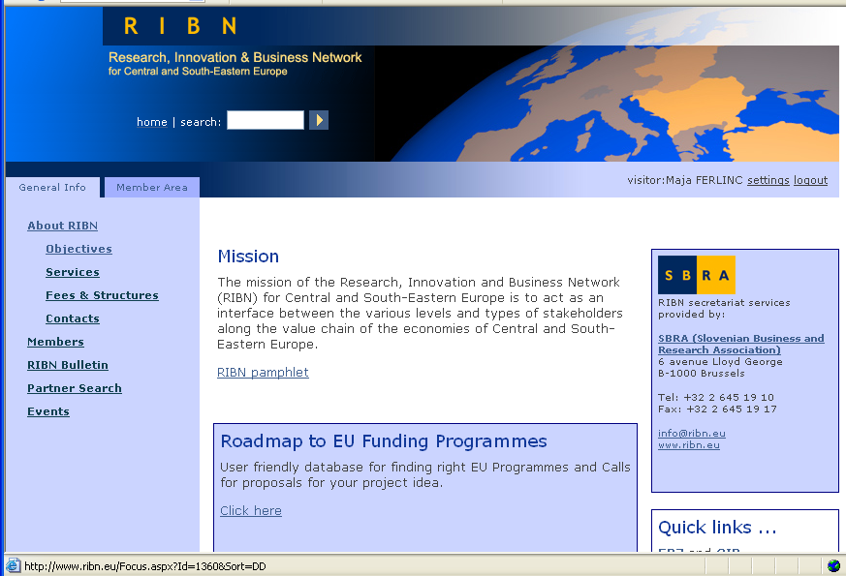
Homepage of RIBN with the link to the Roadmap

Before using the Roadmap, users will get the information on the structure of the EU budget during the period 2007-2013, about the different systems of EU funding and various rules that apply for EC direct funding, Structural Funds and External Aid.
Largely because of the European dimension of the RIBN network, the Roadmap is focused on centrally managed programmes.

Info on EU funding system and sources: http://www.ribn.eu/private/EU_Funding.wlgt

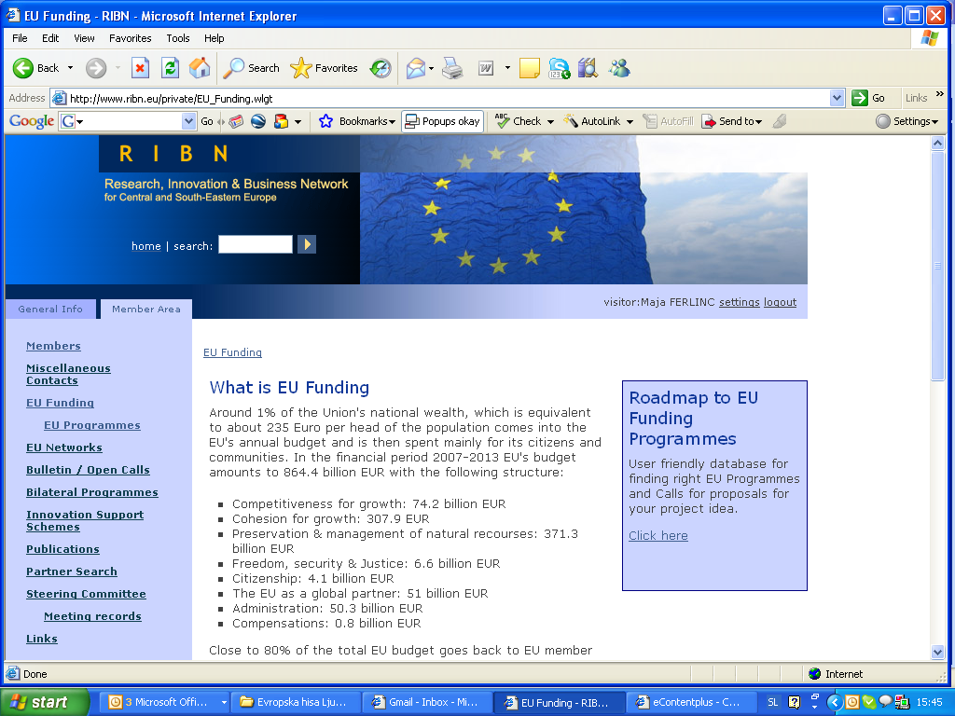
Access to Roadmap to EU funding sources

By clicking on the link in the blue box, users get access to the Roadmap of EU Funding Programmes:
- 7th Framework Programme for Research and Technology Development
- Competitiveness and Innovation Programme (CIP) which is divided into three operational programmes:
  - Entrepreneurship and Innovation Programme (EIP)
  - Information Communication Technologies Policy support Programme (ICT PSP)
  - Intelligent Energy Europe (IEE)
- Instrument for pre-accession assistance (IPA)
- Lifelong learning (Erasmus, Comenius, Leonardo Da Vinci, Grundvig, Transversal programme)
- Territorial cooperation (Interreg IVC)
- eContent Plus

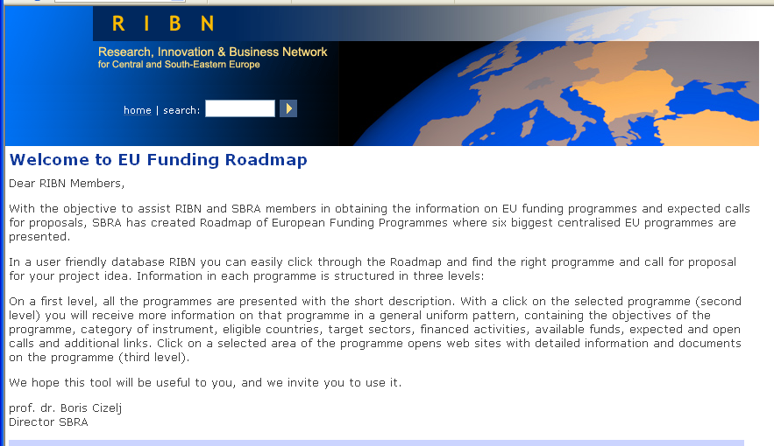

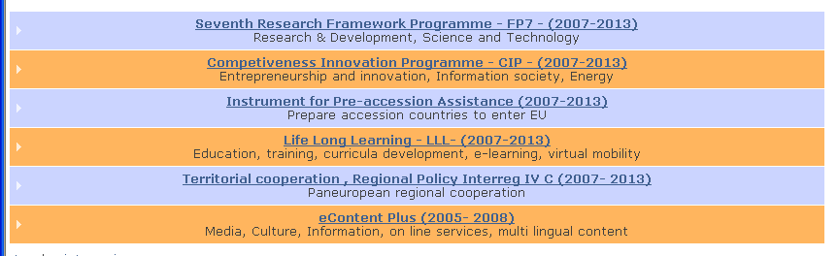
Six centralised EC programmes

When users drag the mouse over the line of the programme, the box opens with a short presentation of the project.

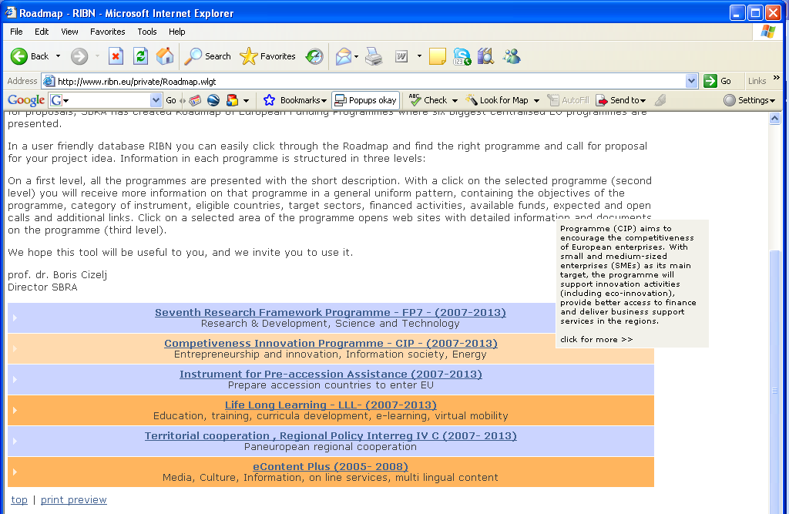
Short presentation of the project in the box

After clicking on the selected programme (a blue or orange box) users access information on the selected programme and sub-programmes. The information is categorised in the following order:

  - Objectives of the programme
  - Category of instruments
  - Categories of eligible countries
  - Categories of eligible partners
  - Targeted sectors
  - Activities financed
  - Available funds for programme and/or individual project
  - Open calls
  - Expected calls
  - Additional information

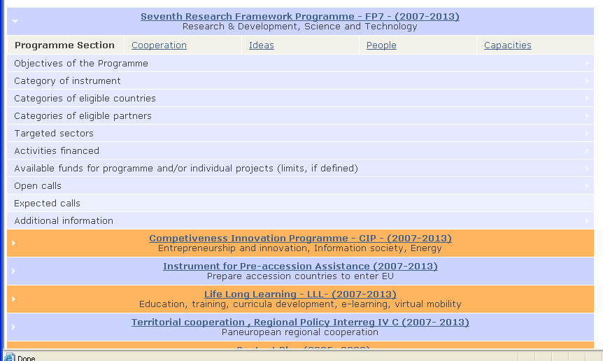

Clicking on a selected category opens the cell with the requested information.

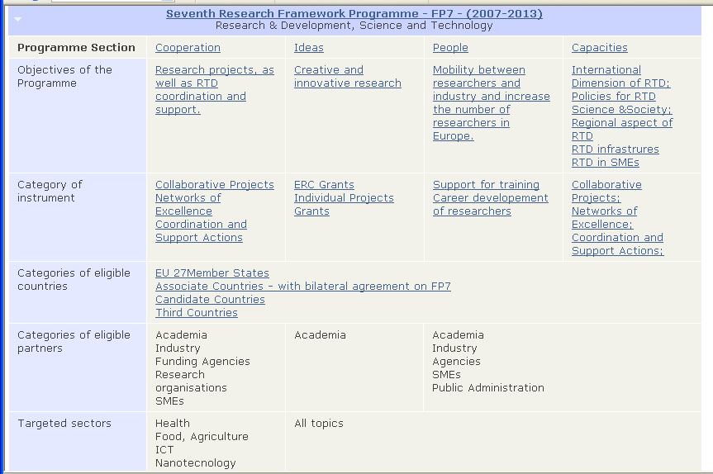
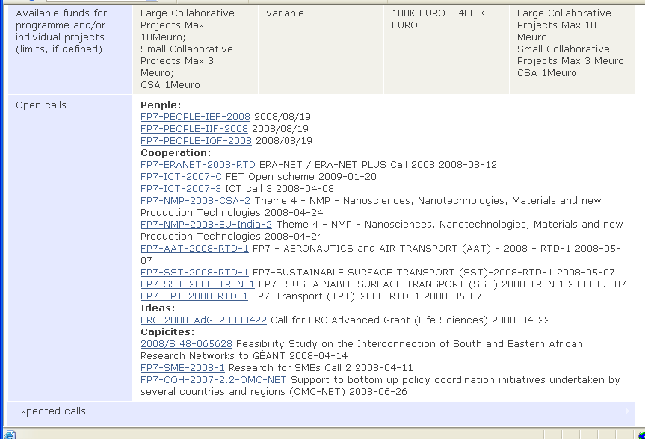
Open calls in FP7

The CORDIS website with information on funding schemes in FP7

Blue text links the user to the official websites of the EU institutions with more detailed information on the programmes or calls.

The principal remains the same when searching information and calls for all six presented programmes.

Annex III

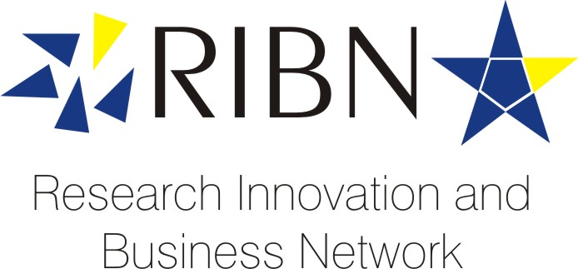

RIBN GENERAL MEETING

Belgrade, 8 May 2008
Sarajevo, 9 May 2008

Draft Agenda:

- Report on Network Activities in 2007
- Activities for 2008
- Network Committee
- Any Other Business

- Belgrade RIBN General Meeting, 8 May 8.30 – 10.00 Conference Room, Serbian Chamber of Economy, Resaves ulica 13-15, 11000 Belgrade

- Sarajevo RIBN General Meeting, 9 May 8.30 – 10.00 Conference Room, Academy of Science and Arts of Bosnia and Herzegovina, Bistrik 7, 71000 Sarajevo

SUMMARY REPORT ON NETWORK ACTIVITIES IN 2007 AND
PRIORITIES FOR 2008

- Major Activities

  - Development of RIBN Roadmap to EU funding programmes
  - Training seminars in Ljubljana with Dr. Sean McCarthy and Zagreb (February)
  - 4 issues of RIBN Bulletin
  - Promotion of Network at various conferences in Brussels
  - Updating the RIBN web portal
  - Updating and processing partner search requests for FP7 Project
  - General Meeting of the Network, 31 May 2007
  - Involvement in 4 European Project together with regional partners, including ECPD (Great IST, BIS-RTD, R4R and WBC-INCO.NET)
  - Preparations for seminars in Belgrade and Sarajevo

- Network Committee and Secretariat

  - Steering Committee to welcome 4 new members: Mr Bojan Šarkić, Montenegro, Prof. dr. Nano Ružin, Macedonia, Mr Bojan Starec, ECPD, Belgrade, Prof. dr. Zoran Trputec, Bosnia and Herzegovina.
  - Changes in RIBN Secretariat: Mr Aleš Šifrer replaced Mr Bojan Terčon as Head of the Secreteriat.

- Challenges / Opportunities /Priorities for 2008

  - Network membership development – slow in 2007, promotion and intensive membership drive - a priority for 2008.
  - Develop proactive information for RIBN members on new entries in the RIBN Roadmap to EU Funding Programmes.
  - Membership fees cover only a fraction of expenses – alternative sources (sponsorships, donations, projects) still to be activated.
  - Progress with preparations of EU Enlargement (Croatia good progress in membership negotiations, EU reconfirmed its committment to Western Balkan countries) provides broader interest for RIBN in the region, but also in EU member states.
  - Establish the links with New Brussels offices (Sarajevo, EU Access, EU Matters, ...) need for closed links with RIBN Secretariat
  - Connections with Brussels Networks (NIROC, ERRIN, …)
  - Updating data base on WBC thematic networks, and interest representation offices in Brussels.

Annex IV

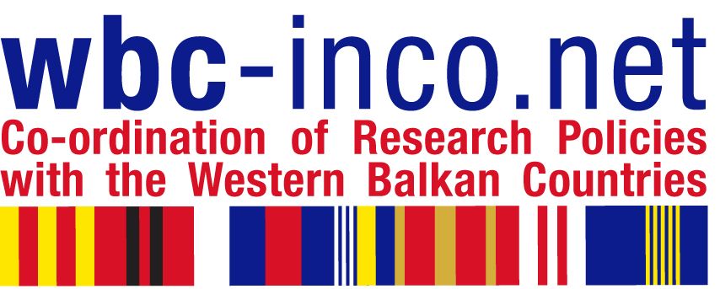

TRAINING PROGRAMME FOR RESEARCH MANAGERS

Organized in the framework of WBC-INCO:NET Project (www.wbc-inco.net) by Slovenian Business & Research Association in collaboration with Serbian Economic Chamber, Ministry of Science, and European Centre for Peace and Development

8 May 2008

Serbian Economic Chamber, Resavska 13-15, 11000 Belgrade,

Introductory Seminar with dr.Sean McCarthy "How to Write a Competitive Proposal for
Framework Programme, FP7"

Seminar Programme:

10.00 Welcome by the Serbian Economic Chamber
Opening address by Mr.Victor Nedović, Deputy Minister for Science and Environment,
Prof.dr.Boris Cizelj: Introduction to EU Programmes

10.30 - 11.30 Dr.Sean McCarthy: The Fundamentals of Framework Programme 7

- structure of Framework 7
- how proposals are evaluated
- different funding schemes (grants)
- which countries can participate

Coffee Break

12.00 - 13.00 How to Write a Competitive Proposal for Framework 7
- the one page proposal
- how to streamline proposal writing.

13.00 - 14.30 Sandwich Lunch offered by Serbian Economic Chamber

WBC-INCO.NET Training Workshop for research managers from companies and research establishments

Workshop Programme:

14.00 - 15.30 dr.Sean McCarthy: Managing Project preparation, Definition of Deliverables, and Consortium Building
Coffee Break

16.00 - 17.00 dr.Sean McCarthy: Budgeting and Reporting

17.00 - 17.30 Leonardo Piccinetti: FP7 Information Sources

INVITATION

TRAINING PROGRAMME FOR RESEARCH MANAGERS

organized in the framework of WBC-INCO.NET Project (www.wbc-inco.net )
by Slovenian Business and Research Association in collaboration with Academy of Science and Arts of Bosnia and Herzegovina, Sarajevo

9 May 2008, Bistrik 7, Sarajevo

Introductory seminar with dr.Sean McCarthy:
"How to Write a Competitive Proposal for Framework Programme, FP7"

Seminar Programme:

10.00 – 10.30 Welcome by prof.dr.Miloš Tričković, Academy of Science and Arts of Bosnia and Herzegovina
Mr.Osman Topčagić, Director of Directorate for European Integration - Bosnia and Herzegovina on its Integration Road to EU
Prof.dr.Boris Cizelj: Introduction to EU Funding Programmes
Ammar Mirašćija: The Experience of Bosnia and Herzegovina in Framework Programmes

10.30 - 11.30 dr.Sean McCarthy: The Fundamentals of Framework 7
- structure of Framework 7
- how proposals are evaluated
- different funding schemes (grants)
- which countries can participate

Coffee Break

12.00 - 13.00 How to Write a Competitive Proposal for Framework 7
- the one page proposal
- how to streamline proposal writing.

13.00 - 14.00 Sandwich Lunch offered by Academy of Science and Arts, BIH

WBC-INCO.NET Training Workshop for research managers from academies, research establishments, universities, and companies

Workshop Programme:

14.00 - 14.30 dr.Gilbert Fayl: Involving Academies
14.30 - 15.30 dr.Sean McCarthy: Managing Project preparation, Definition of Deliverables and Consortium Building.
Coffee Break

16.00 - 17.00 dr.Sean McCarthy: Budgeting, Reporting
17.00 - 17.30 Leonardo Piccinetti: FP7 Information Sources

Annex V

  NOVA GORICA |  |  | 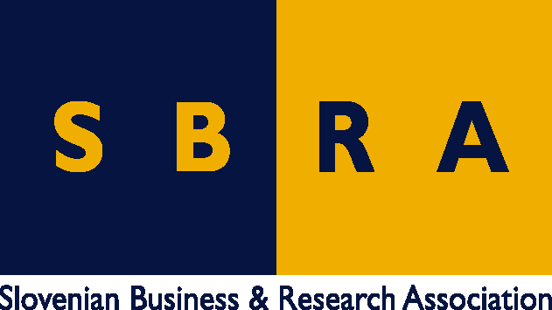
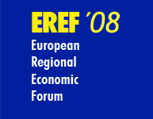  www.eref.si | Public-private partnerships and private funding of RTD, innovation and education activities  Nova Gorica, Slovenia, 5-6 June 2008

Programme EREF-2008

Thursday 5 June

08.00 Registration

09.00 Opening

Welcome Addresses:
Mirko Brulc, Major of Nova Gorica,
Niko Trošt, President of HIT, the General Sponsor,
dr.Ivan Žagar, Slovenian Minister for Local Self-Government and Regional Policy.

Keynote Address:

Dr.Žiga Turk, Slovenian Minister for Development:
Lisbon Agenda in Slovenia and the Views of Slovenian Presidency on Imperatives for European Knowledge Economy

Short Topical Addresses by senior representatives of 5 Guest Regions: Styria, Friuli Venezia Giulia, Prague, Vojvodina, Istanbul.

EREF-2008 Guest Regions and Partners
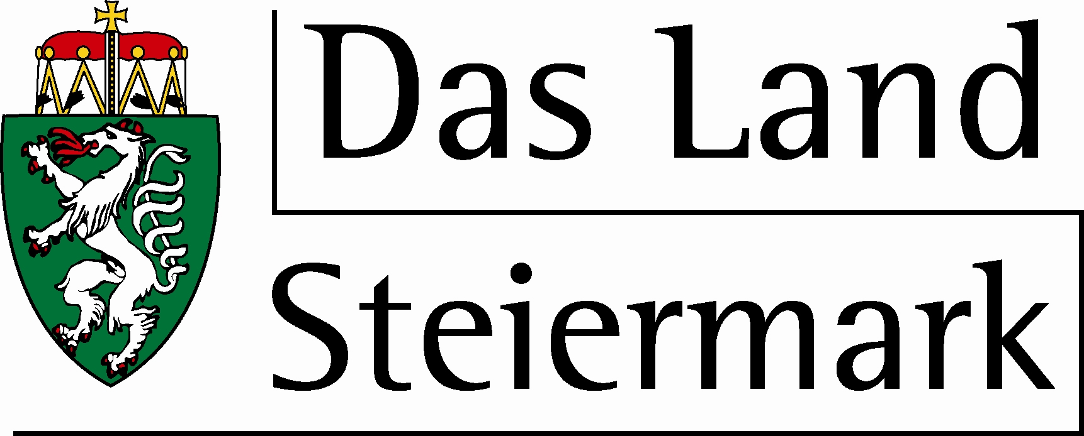  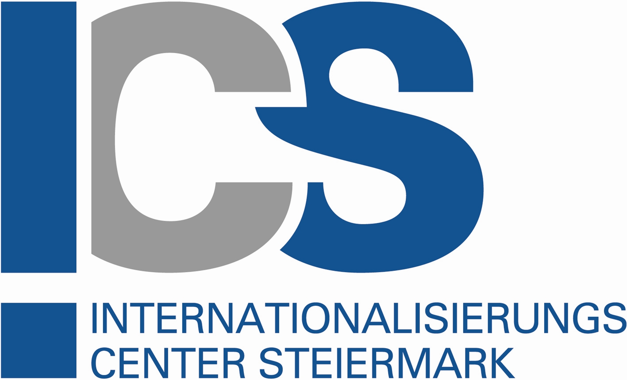 | 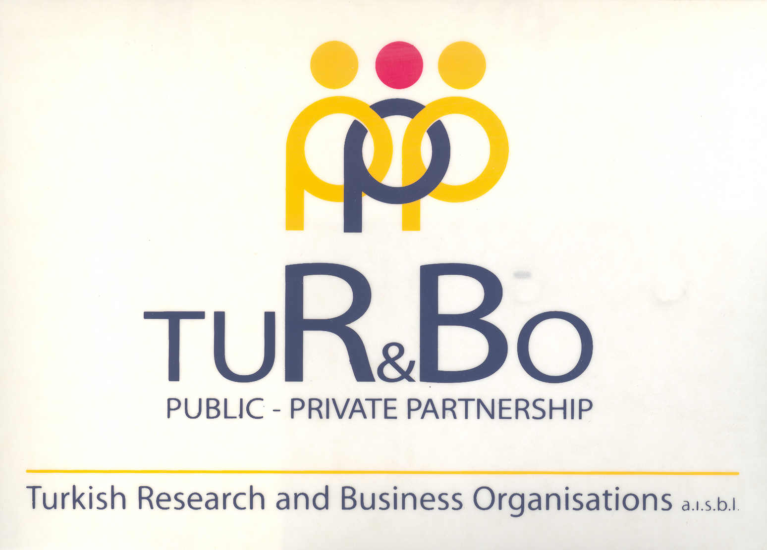 | 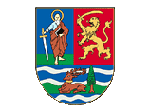  A P Vojvodina |  |  | 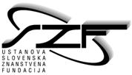

10.00 Introductory Panel: Building a Competitive Europe of Knwledge

- Progress Towards ERA – Achievements and Challenges, James Gavigan, European Commission, DG RTD
- Presenting the Dimensions of European Knowledge & Innovation Gap – Scenarios of Non-Lisbon – prof.dr.Pavle Sicherl, Director SICENTER
- Regional Lisbon Monitor - Committee of the Regions
- European Funding Support for companies’ R&D Effort, with special reference to SMEs - Mrs.Maive Rute, Director in DG Enterprise and Industry
- Integrating RTD, Innovation and Education Policies at the Regional Level – lessons from Canada - Prof.Howard Alper, Chair of Canada’ Government Science, Innovation and Technology Council

Discussion

LUNCH (13.00 – 14.30)

15.00 Implementing Good Practice in PPP and Private Funding in RTD, Innovation and Education at the Regional Level

      - Bottom-up Approach to Lisbon Agenda Implementation - Lessons from Sweden Lotta Finstorp, County Commissionar, County Council in Sormland; Benita Vikström, Mayor, Oxelösunds Municipality;
      - Science Education – a Precondition for Knowledge Society; Professor Yves Quere, French Academy of Sciences;
      - Regional and national Potential for creating “Power Brands” - prof.dr. Jürgen Häusler, Interbrand Zintzmeyer & Lux, Zürich and dr Hermann Drummer, Pleon, Brussels.
      - Science Parks – Generators of Innovation and Growth: Prof.Malcolm Parry, The Surrey Research Park, UKSPA;
      - Regional Innovation Policy Implementation through PPP – Lessons from the Finish Experience; Kyösti Jääskeläinen, Executive Director, TEKEL;
      - Corporate Impact on Business School Curricula – an Instrument of Bridging universities and Business: Gert Van Mol, The Wall Street Journal;
      - PPP as an Instrument for Stimulating Business-Academia Collaboration – Guidelines developed in the BIS-RTD Project –presented by prof.dr.Stane Pejovnik, Dean, Faculty of Chemistry and Chemical Technology, University of Ljubljana.

16.30 - 18.00 Parallel Events:

(A) Workshop on Inter-regional Technology Transfer Models

(B) Meeting of regional/local Lisbon Agenda Coordinators

20.00 Dinner offered by EREF-2008 Guest Regions: Styria, Friuli Venezia Giulia, Prague, Vojvodina, Istanbul, and Slovenia.

Friday 6 June

09.00 Keynote Addresses
Role of European Regions in strengthening Knowledge Economy – Luc van den Brande, President, Committee of Regions

Linking Cohesion Funding with Building European Regional Knowledge Economies – Prof.Danuta Hübner, Member of the Commission responsible for Regional Policy

10.00 Towards Forum’s Conclusions and Recommendations

Reports from Preparatory Workshops: Presentation of Draft-Recommendations by the Rapporteurs

Workshop A: Regional Support to Innovation and Internationalization of SMEs, InternationalizierungsZentrum Styria, Graz, Rapporteur Michael Azodanloo,

Workshop B: Industry-Academia Collaboration, TURBO, Istanbul, Rapporteur Mehmet Gokgoz,

Workshop C: Participation in EU RTD Programmes – Instrument of building Knowledge Society; ECPD/Vojvodina Regional Government, Novi Sad, Rapporteur Bojan Starec

  - – 11.15 Coffee Break

Workshop D: PPP in Research Priority Setting – particular emphasis on Energy, ČEZ, Praha, Rapporteur

Workshop E: Role of Science and Technology Parks in boosting regional knowledge-based competitiveness; Area Park Trieste, Rapporteur Gabriele Gatti

Workshop F: Philanthropic Funding’s Contribution to Building Knowledge Economy, Slovenian Science Foudation, Portorož, Rapporteur Edvard Kobal

Comments on draft Recommendations by Commissioner for Regional Policy Prof. Danuta Hübner, and Slovenian Minister for Local Self-Government and Regional Policy dr.Ivan Žagar

LUNCH (13.00 – 14.30)

  - Discussion

16.00 Adoption of Conclusions and Recommendations

16.30 Topic and date of EREF-2009 and Closure

