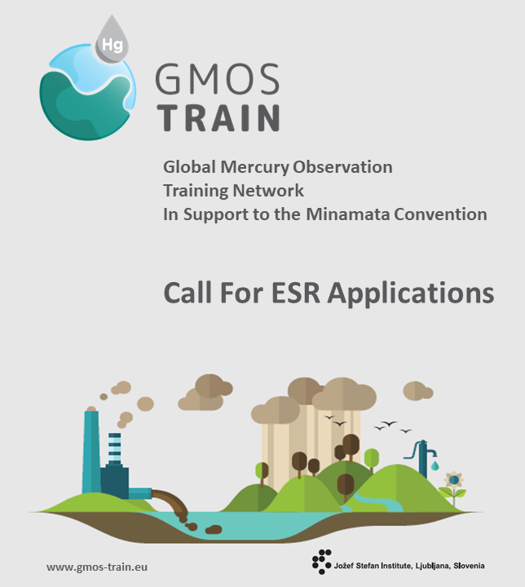

15 ESR positions are open to train a new generation of environmental scientists who will work on research topics of great global importance.

The Marie Skłodowska-Curie Action “Global Mercury Observation and Training Network in Support to the Minamata Convention” is an international research project, coordinated by Prof. Milena Horvat from the Jožef Stefan Institute (JSI) and is financed under the funding line “excellent science” of the Horizon 2020 research and innovation programme of the European Commission. In this very competitive scheme the project received total score 100%. It includes 11 European project partners and participates with eminent research institutions, such as Harvard University and MIT, and other organisations, such as UN Environment, JRC Ispra and eminent NGOs.

The overall objectives of the GMOS-Train network are:

- to provide urgently needed training in Hg science within the context of the UNEP Minamata Convention, and
- to fill key knowledge gaps in biogeochemical Hg cycling linking anthropogenic emissions and Hg in marine food webs.
ESRs will be trained through a structured and comprehensive programme and will not only learn the theory but will gain first-hand lab experience. The partners engaged in the project will work closely together, with each of the partners supervising at least one research project. All ESRs will spend time not only at the hosting institution but also in one of the other partner universities/research centers/regulatory agencies/companies involved in GMOS Train project throughout Europe. Being trained in highly relevant research topics will enhance researchers career prospective and employability. The GMOS-Train aims to recruit outstanding and highly motivated ESRs to meet the ambitious goals of the project.

All applications must be submitted by means of on-line application on the official GMOS-Train project website: www.gmos-train.eu. Deadline for application is February 29th 2020.

Please find details about the application process and modalities at www.gmos-train.eu.

We are looking forward to your application!

Best regards,
Prof. Dr. Milena Horvat, JSI, Project Coordinator CONTACT
Prof. Dr. Milena Horvat, JSI
E: milena.horvat@ijs.si
T: +386 1 588 5287
www.gmos-train.eu

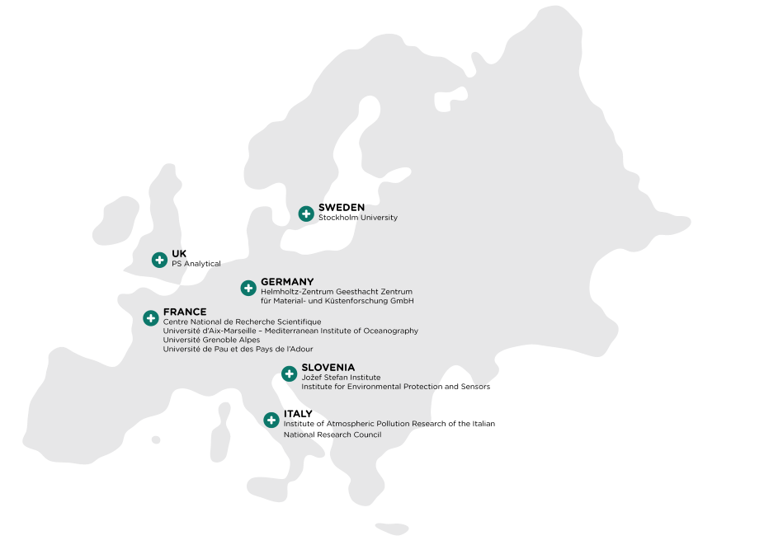
ESR Hosts

COORDINATING ORGANISATION
Jožef Stefan Institute on behalf of the GMOS-Train consortium

RESEARCH FIELD
Environment and Health Science

RESEARCH PROFILE
Early Stage Researcher (ESR)

APPLICATION DEADLINE
29 February 2020 23:00 – CET (Europe/Brussels)

SELECTION COMPLETED
by 31 March 2020

ESR SELECTED AND RECRUITED
by the deadline 30 September 2020

EU RESEARCH FRAMEWORK PROGRAMME
H2020 / Marie Skłodowska-Curie Actions

MARIE CURIE GRANT AGREEMENT NUMBER
860497

WORK LOCATION
Multiple locations
(secondments to project partners)

TYPE OF CONTRACT
Temporary

JOB STATUS
Full-time, 36 Months

INDICATIVE WORKING HOURS PER WEEK
40

9 academic and 2 industrial partners
in 6 countries

Participating Organisations
(ESRs secondments)

Arctic Monitoring and Assessment Programme | AMAP | Norway
United Nations Environmental Programme | UNEP | Switzerland
Massachusetts Institute of Technology | MIT | USA
Harvard University | Harvard | USA
Institut de Recherche pour le Développement | IRD | France
Swedish Polar Research Secretariat | SPRS | Sweden
European Environmental Bureau | EEB | Belgium
Tekran | Tekran | Canada
Lumex | Lumex | Germany/Russia
Dutch National Standard Laboratory | VSL | The Netherlands
Aristotle University of Thessaloniki | AUTH | Greece
Meteorological Synthesizing Centre – East of EMEP | MSC-E | Russia
International Postgraduate School Jožef Stefan | IPSJS | Slovenia
Université Paul Sabatier | UPS | France
Université Bretagne Loire | UBL | France

Eligibility Criteria
GMOS-Train is looking for a broad international representation of early stage researchers. The network clearly acknowledges its responsibility for the recruitment of the researchers, their working and living conditions, as stated in the document “The European Charter for Researchers - Code of Conduct for the Recruitment of Researchers”. Gender equality and minority rights will also be promoted in the selection process. There is no age limit.
- MOBILITY
The positions are open to all nationalities. However, your application has to comply with the European Commission’s Mobility Rules, meaning that at the time of recruitment you must not have resided or carried out your main activity (work, studies, etc.) in the country of the host organisation for more than 12 months in the 3 years immediately before the reference date (indicative start of the employment contract, Month Date 2020). Compulsory national service and/or short stays such as holidays are not taken into account (European Commission’s Guide for Applicants).
- EARLY-STAGE RESEARCHER (ESR)
In case you have already gained prior work experience in academia, you shall be in the first four years (full-time equivalent research experience) of your research career at the time of recruitment by the host organisation and have not been awarded a doctoral degree. Full-time equivalent research experience is measured from the date when you obtained the degree entitling you to embark on a doctorate, even if a doctorate was never started or envisaged. Part-time research experience will be counted pro-rata (European Commission’s Guide for Applicants).
- RELEVANT UNIVERSITY DEGREE
master’s degree or equivalent in Environmental and Health Science or related fields.
- EXCELLENT PROFICIENCY OF THE ENGLISH LANGUAGE

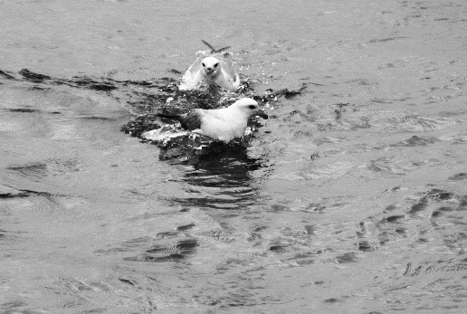
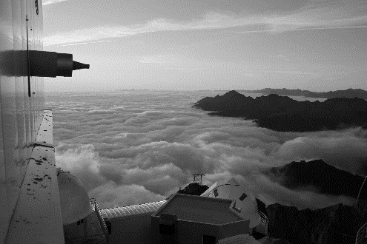
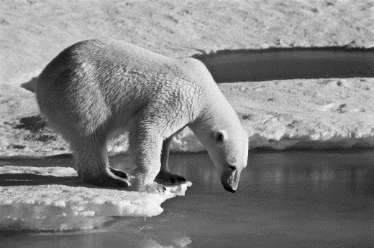

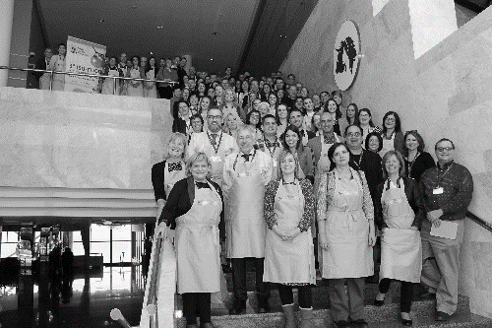
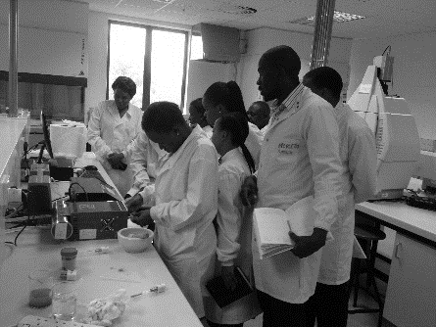
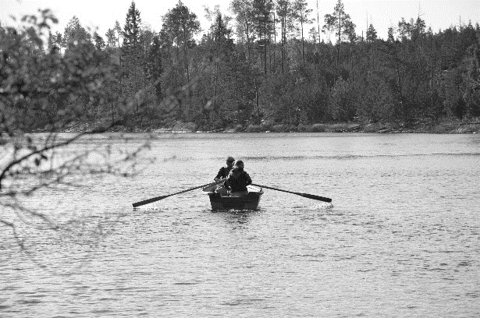

Selection Process
In case an individual researcher is interested in several advertised ESR projects, he/she may apply for a maximum of three specific ESR projects and list their order of preference.
The selection committee will check applications against the following criteria:
- Scientific background and potential as indicated by candidate experience.
- Fit to a research project.
- Evidence of ability to undertake research.
- Evidence of working within groups or teams.
- Impact and benefit of the proposed training to the candidate’s research career.

Three candidates will be short-listed for each research project and invited to an interview (interviews by video link will be held if candidates are not able to travel).
Interviews will consist of two parts:
1) a short presentation by the candidate followed by questions and answers, and
2) competence-based interview.

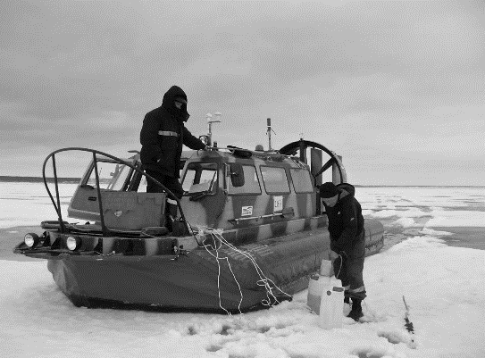
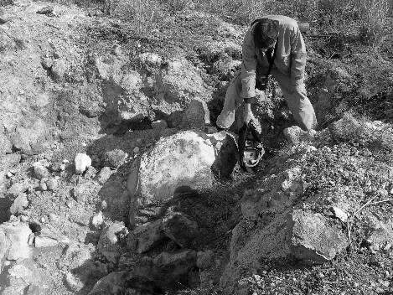

Employment Conditions

The selected candidates are employed with a fulltime contract. The salary follows the Marie Curie-Skłodowska ITN funding Scheme. The researcher is hired under an employment contract and benefits from a monthly living allowance, social security cover, plus a mobility and family allowance.

A career development plan will be prepared for each fellow in accordance with his/her supervisor and will include training, planned secondments and outreach activities in partner laboratories of the network. The ESR fellows are supposed to complete their PhD thesis by the end of the 3rd year of their employment. For more information please visit the Marie Curie-Skłodowska website and GMOS-Train website.

ESRs Key Responsabilities
- To manage and carry out the research projects within 36 months.
- To write a PhD dissertation.
- To participate in research and training activities within the GMOS-Train network.
- To write articles for scientific peer reviews.
- To participate in meetings of different GMOS-Train consortium bodies.
- To disseminate the research in the scientific community (international conferences) and non-scientific community, by outreach and public engagement.
- To liaise with the other research staff and students working in broad areas of relevance to the research project and partner institutions.
- To write progress reports and prepare results for publication and dissemination via journals, presentations and the web.
- To attend progress and management meetings as required and network with the other research groups.

ESRs Benefits
- Prestigious EU fellowship.
- Highly competitive and attractive salary and working conditions.
- Excellent training programme covering health and environment science and state-of-the-art technologies.
- Develop multidisciplinary research skills.
- Be part of a team of leading scientists in different fields of academia.
- Establish a professional network in industry and academia.
- Visits and secondments to other project partners within industry and academia for up to 30% of your appointment period.

ESR Projects
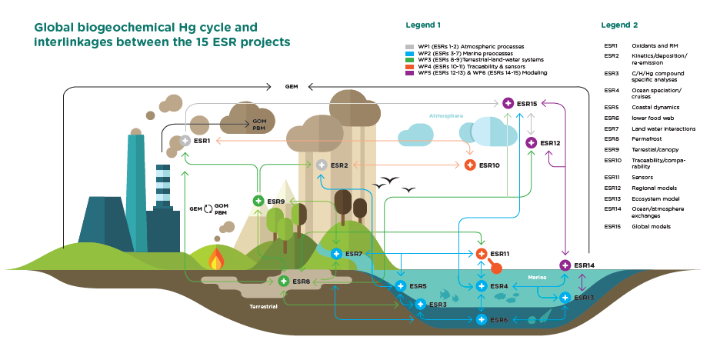

ESR 1
Project Title: Understanding atmospheric Hg redox transformations from novel field observations and 3D atmospheric Hg models.
Host: UGA, Grenoble, France
Supervisor: A. Dommergue
Co-supervisor: : J. Sonke (CNRS)
Enrolment in Doctoral degree: Université Grenoble Alpes, France
Context: Atmospheric oxidation of the dominant emitted Hg(0) form is a key process whereby Hg from natural and anthropogenic sources is converted to more soluble and reactive Hg(II) species that will be deposited to ecosystems. Recent theoretical, field and experimental studies have proposed new atmospheric Hg redox pathways, including alternative oxidants, and direct photoreduction of Hg(II) forms. These new pathways need to be integrated in atmospheric Hg models and tested against observations of atmospheric Hg and oxidant dynamics.
Objectives: To improve understanding of atmospheric Hg observations including the role of key oxidants, photoreduction and re-emissions.
Methodology & Expected Results: This project relies on previously made Hg observations, and on state of the art atmospheric Hg models. The spatial and temporal variability of Hg(0) and Hg(II) species concentrations along with some oxidants (BrO, NO_{x}, O₃) will be investigated in regions where high oxidation rates are observed or suspected (polar regions, high altitude sites, tropical regions). An improved understanding of Hg(0) re-emission sources (snow, sea-ice, ocean, land) and their role in the atmospheric Hg budget will be proposed using available 1D and 3D atmospheric models. Improvement of reactions schemes and parametrization of Hg(0) oxidation and Hg(II) reduction using the latest version of the models (i.e. GEOSChem 3D) will be tested in high oxidation environments, using recent UGA/CNRS data and GMOS, AMNET data. ESR1 will work in close collaboration with ESR2, 10 and 14.
Planned secondment(s):
PSA/VSL (W. Corns/I.Krom) 1 month, traceable calibration for GEM and GOM, seconded together with ESR2 to collaborate with ESR10; CNRS (J. Sonke), 1 month, analytical techniques; MIT (N. Selin), 3 months, integrate novel field observations into global GEOS-CHEM 3D model; HZG (J. Bieser), 1 month, integrate novel field observations into 3D regional models, collaborate with ESR14.

ESR 2
Project Title: New experimental constraints on atmospheric Hg red-ox reactions.
Host: JSI, Ljubljana, Slovenia
Supervisor: M. Horvat
Co-supervisors: : A. Dommergue( UGA), J. Sonke (CNRS)
Enrolment in Doctoral degree: International Postgraduate School Jožef Stefan
Objectives:
The main objective is to understand aqueous Hg red-ox mechanisms and rates from an experimental perspective. This includes the Hg red-ox behaviour of Hg species in marine waters, atmospheric waters and in aerosols, in order to better understand deposition of oxidised fractions of Hg and re-emission of volatile inorganic Hg species, and the two-way flux of Hg species between oceans/atmosphere and land/atmosphere. Close collaboration with ESR1, and ESRs 4, 5, 9, 10, 12, 14, 15
Expected Results:
(i) Experimental kinetic rate constants for reduction reactions in the aqueous phase for Hg(II) complexes in seawater, rainwater, cloud water, aerosols , and of GOM in the gas phase under different wavelength regions (using solar simulator) (ii) validation of laboratory experiments with complementary field based experiments, and (iii) mechanistic understanding of photochemical reactions from the Hg stable isotope composition of products and reactants and (iv) improved representation of aqueous and gaseous redox processes in 3D regional and global Hg models (3 papers).
Planned secondments:
CNRS (J. Sonke) UGA (A. Dommergue) 2 months, photochemistry mechanisms studied by Hg stable isotope composition of products and reactants, Harvard (E. Sunderland), 1 month, training on modelling of biogeochemical cycling of Hg in different environmental compartments; HZG (C. Schrum, J. Bieser), 1 month, incorporation of new kinetic data into regional and global models, joint collaboration with ESR14; joint publication.

ESR 3
Project Title: Combining carbon, hydrogen and Hg compound specific isotope analysis to understand MMHg origin.
Host: CNRS, Toulouse, France
Supervisor: D. Point
Co-supervisors: J. Sonke (CNRS); A. Lorrain (IRD)
Enrolment in Doctoral degree: Paul Sabatier University, France
Context:
All humans are exposed to toxic monomethyl-Hg (MMHg) when we consume marine fish. The origin of MMHg in marine ecosystems is however not well understood. MMHg formation is likely microbial, but could be abiotic. Which microbes methylate marine inorganic Hg is not known, and the role of the gaseous dimethyl-Hg form as a precursor or product of MMHg is also not known. The isotopic composition of Hg, carbon and hydrogen carry information on the sources and transformation pathways of MMHg, and are the topic of investigation in this PhD project.
Objectives:
to develop novel carbon (δ¹³C) and hydrogen (δD) isotopic tracers of the ’methyl’ group of the MMHg (CH₃Hg) compound; to couple novel C/H isotopic tracers with Hg stable isotopic analysis; to explore and fingerprint the fundamental mechanisms at the origin of MMHg formation under laboratory-controlled experiments, in the field, during oceanographic cruises and in biological samples originating from different ocean basins.
Methodology and Expected Results:
This PhD project involves analytical chemistry, method development, analysis of environmental, biological samples, and minor fieldwork. The ESR will (i) validate methodologies for the 3D (δ¹³C-δD-δ²⁰²Hg/Δ¹⁹⁹Hg) isotopic analysis of MMHg in natural samples at low concentrations (zooplankton); (ii) study 3D (δ¹³C-δD-δ²⁰²Hg/Δ¹⁹⁹Hg) isotopic variations of MMHg during abiotic and biotic Hg methylation experiments, under controlled laboratory conditions; (iii) document the 3D isotopic variations of MMHg in marine organisms collected from different study sites of ESR 4, 5, 6, 7. The trophic ecology and habitat of these organisms will also be documented by complementary analysis of δ¹³C, and δ¹⁵N signatures on individual amino acids.
Planned secondments:
IRD (A. Lorrain), 2 months, investigation of the 3D (δ¹³C-δD-δ²⁰²Hg/Δ¹⁹⁹Hg) signatures of MMHg in marine food web in relation with marine predators foraging ecology; SU (S. Jonsson), 1 month, the role and interaction of CH₃Hg with DOM; UPPA (D. Amouroux), 3 months, Hg/C isotopic fractionation during lab biomethylation reactions.

ESR 4
Project Title: Marine Hg species dynamics and distribution.
Host: AMU, Marseille, France
Supervisor: L.E. Heimbürger-Boavida
Co-supervisors: D. Amouroux (UPPA); M. Horvat (JSI)
Enrolment in Doctoral degree: Université d'Aix-Marseille, France
Context:
Mercury is one of the least concentrated elements in the ocean, and its complex biogeochemical cyling drives ultimately the biomagnification of methylmercury into marine fish. Several key knowledge gaps must be filled to understand the marine biogeochemical Hg cycle. 1. One of the largest Hg flux occurs at the ocean-atmophere interface. Dispite the fact that This Hg exchange flux remains ill-quantified despite the fact that it is thought to be bigger than the annual anthropogenic Hg emissions. 2. The ocean remains undersampled and not all ocean basins have been mapped for Hg species. 3. Volcanic emissions are the only primary natural Hg source. Yet the magnitude of hydrothermal Hg emissions to the ocean remains virtually unknown. The UNEP Global Mercury Assessement 2018 has called to address those three knowledge gaps for a better understand of the global and oceanic mercury cycling.
Objectives:
ESR 4 will target key knowledgegaps of the marine biogeogemical cycle of mercury: 1. Refining the Hg flux at the ocean-atmopshere interface. The ESR will develop a first high resolution time-series of combined marine (DGM, other Hg species and methylation/demethylation incubations) and atmospheric Hg observations at a coastal Mediterranean site, 2. MapMap Hg species in the global ocean. The ESR will produce Hg speciation and incubation data in the only uncharted ocean basin, thethe Indian Ocean, 3. The ESR will sample hydrothermal vents during the Indian Ocean cruise and compare with samples from other hydrothermal vent sites. Collaboration with ESRs 1, 3, 5, 6, 11,13,14, 15.
Expected Results:
Provide a DGM time-series to better constrain the large exchange flux at the ocean-atmosphere interface (paper 1). Provide high-resolution full depth open ocean description of all Hg species (tHg, MMHg, DMHg, Hg(0), DGM), and Hg methylation/demethylation rates for thethe Indian Ocean, including some hydrothermal vents (1 paper). New observations will feed the GEOTRACES global database and be used to confront and update state-of-the-art numerical global open ocean models.
Planned secondments:
Tekran (E. Prestbo), 1 month, M4, implementation of DGM/TGM time-series measurements; UPPA (D. Amouroux), 1 month, M10, acquisition of isotopically-label incubation experiments techniques, and to implement a coordinated approach between all coastal and open ocean ESRs; JSI (M. Horvat/J.Kotnik), 1 months, M13, improvement and implementation of discrete DGM measurements (joint publication),HZG (C. Schrum, J. Bieser), 1 month, M32, to confront new observational data with models.

ESR 5
Project Title: MMHg sources in coastal ecosystem: new molecular and isotopic experimental speciation approaches.
Host: UPPA, Pau, France
Supervisor: D. Amouroux
Co-supervisors: R. Guyoneaud (UPPA), C. Schrum (HZG)
Enrolment in Doctoral degree: Université de Pau et des Pays de l'Adour, France
Objectives:
(i) to investigate major microbial and photochemical processes connected to the formation of MMHg (and DMHg) in coastal marine ecosystems (Atlantic and Mediterranean coastal, shelf and/or margin stations), (ii) to understand the dynamic of MMHg formation/distribution from coastal to marginal marine areas in collaboration with ESR 4, 6, 7. ESR5 will collaborate with ESR3 on isotopic tracers incubation techniques, with ESR 7 on the role of coastal DOM, with ESR11 to test biosensor information and provide data for ESR13 for modelling purposes, and Collaboration with ESRs 3, 4, 6, 7, 11, 13.
Expected Results:
Methylation, di-methylation or demethylation rates at various depth andandand compartments of the water column as defined by critical biogeochemical parameters (e.g., microbial diversity and hgcA “methylation” genes; sunlight irradiance and DOM chromophoric properties) affecting Hg transformations in coastal, shelf and/or margin stations. Provide new molecular and isotopic information on the transformations pathways of the methylated Hg species in coastal environments (3 papers).
Planned secondments:
IOS/JSI (A. Lobnik, A. Lapanje), 1 month, , bioavailable fraction (biosensor) vs MMHg reactivity in coastal waters (combined with ESR11); SU (S. Jonsson), 2 months, the role of DOM in MMHg dynamics; HZG (C. Schrum, J. Bieser), 1 month, to make use of novel experimental data with models developed by ESR13 (joint paper – see D5.1).

ESR 6
Project Title: BioconcentrationUptake, bioconcentration and biomagnificationbiomagnification of mercury into phyto- and zooplanktonzooplankton
Host: IFREMER, Nantes, France
Supervisor: J. Knoery
Co-supervisors: L.E. Heimbürger-Boavida (AMU), D. Point (CNRS)
Enrolment in Doctoral degree: University of Nantes, France
Context:
Seafood and especially marine fishfish are the primariy source of toxic monomethyl-Hg (MMHg). The ) in Europeans. However, the processes responsible for MMHg production within marine ecosystems are however not yet wellremain poorly quantified. an understood. Possible pathways include abiotic, microbial, and/or planktonic MMHg production. .This ESR will studystudy the role of marine particles, both living and non-living for marine MMHg production. All planned experiments are designe to mimic natural conditionconditions as closeclosely as possible and will be realized in mesocosms located atat the Atlantic and Mediterranean coastcoast. Laboratory experiments may also be necessary.
Objectives and Methodologies:
The ESR will examine Hg and MMHg sorption and uptake rates ontoonto/into a slectionsselection of marine particle types, including non-livingnon-living particulate organic matter, microbes, phyto- andphyto- and zooplankton. .This work will be realizedrealized with dedicated, controlled experiments,, both in the laboratory and in mesocosms at coastal sites. This. This ESR will use state-of-the-art techniques, including analytical isotope tracing methods, to deconvolute Hg and MMHg dynamics. In parallel the ESR will work on data from French Atlantic coastal field sampling campaigns. The mesocosm and field. Themesocosm and f studies will be conducted in collaboration with ESR4 and ESR7 to cover three contrasting environments and their landenvironments and their land to sea continuumscontinuums (Atlantic OceanOcean, Mediterranean and Baltic seasseas).
Expected Results:
Having generated original, newnew Hg speciation data and uptake rates between different marine particle size classes ranging from field-flow fractionated organic matter, bacteria- and phyto-,phyto-, and zooplankton, the ESR will author 2 publicationspublications and contribute to aa joint paper defined in D2.1.2.
Planned secondment(s):
With co-advisors: CNRS (D. Point), 2 months, isotope tracing analysis collaboration with ESR3 (joint paper); AMU (L. E. Heimbürger-Boavida), 1 month, to review, compare, and evaluate results obtained by ESR6ESR6 with data of ESR4;
With partners : HZG (J. Bieser), 1 monthmonth, to test newly obtained data within model developed by ESR13.

ESR 7
Project Title: The role of terrestrial Hg in coastal and open oceans.
Host: SU, Stockholm, Sweden
Supervisor: S. Jonsson
Co-supervisors: E.Sunderland (Harvard), D. Amouroux (UPPA), L.E. Heimbürger-Boavida (AMU)
Enrolment in Doctoral degree: Stockholm University, Sweden
Context:
Biological uptake of inorganic Hg by bacteria (Hg^{II}) and monomethylmercury (MMHg) at the base of aquatic food web are critical steps in Hg’s biogeochemical cycle linking its sources to its inherent environmental risk. While primarily smaller dissolved complexes of Hg are available for biological uptake, most of the Hg in soil, sediment and inland waters is bound to particles and larger dissolved complexes. The bioavailability of Hg^{II} and MMHg in a natural system is therefore not obvious and, so far, under-studied. This project aims to understand availability of Hg^{II} and MMHg for biological uptake during transport from land to sea.
Objectives:
Gain improved understanding of the fate and reactivity of terrestrial Hg along land to sea transects by i) applying novel approaches to study refractory concentrations of Hg, ii) study the availability of Hg when complexes to dissolved organic matter (DOM) from terrestrial and marine environments for photochemical and bacterial transformation reactions, and biological uptake (sampling in e.g. Swedish Baltic coast, French Atlantic and Mediterranean coast and Northern Adriatic coasts, within the framework of ESR 4,5,6) and iii) comparison of experimental and field derived data on the availability of Hg-DOM complexes for biological uptake with the biological reactivity of Hg-DOM complexes measured using the biosensors (in collaboration with ESR 5 and 11), Collaboration with ESR 3, 5, 6, 11, 12, 13, 15
Expected Results:
Provide data on refractory concentration of Hg transported from the terrestrial compartment to coastal and open seas on particles and ii) the availability of Hg- and MeHg complexed with DOM extracted from contrasting land-to-sea transects and open ocean. (2 papers)
Planned secondments:
Tekran (E. Prestbo), 1 month, training on conventional analytical methods for Hg speciation; IJS/IOS (M. Horvat), 2 months, testing of new biosensor in laboratory setting and to apply biosensors to Hg-DOM extracts from experimental systems (ESR11); Harvard (E. Sunderland), 1 month, consideration of the obtained results in the modelling framework; HZG (C. Schrum, J. Bieser), 1 month, to make use of novel experimental data with models developed by ESR13.

ESR 8
Project Title: Release of mercury from thawing permafrost.
Host: SU, Stockholm, Sweden
Supervisor: S. Jonsson
Co-supervisors: K. Gårdfeldt (SPRS) and D. Kocman (JSI)
Enrolment in Doctoral degree: Stockholm University, Sweden
Context:
In the recently published special IPCC report on The Ocean and Cryosphere in a Changing Climate it was concluded that permafrost temperatures have increased by 0.39 ± 0.15°C in zones with continuous permafrost during the last decade. Widespread accelerated permafrost thawing is predicted for this century and beyond. This threatens to remobilize large amounts of Hg currently ‘locked’ in Arctic permafrost soils to nearby lakes and estuaries and to the global biogeochemical cycle of Hg. Yet, future risk of Arctic Hg stocks is poorly understood. This project aims to unravel how a warmer climate can perturb the biogeochemical cycle of Hg and permafrost Hg stocks.
Objectives:
The ESR will study (i) to what extend Hg is mobilized to the atmosphere and downstream systems; (ii) if warmer climate and subsequent degradation of organic matter turns thawing permafrost soils into hotspots for Hg methylation, and (iii) what risk Hg in thawing permafrost pose for the local environment and for altering the global cycle of Hg. Field-work will be conducted at Abisko National Park in northern Sweden, Collaboration with ESRs 1, 3, 7, 9, 11, 12, 15
Expected Results:
Process based understanding of mobility and intercompartmental transformation processes of Hg stored in thawing permafrost (2 papers).
Planned secondment(s):
IJS/IOS (M. Horvat, A. Lapanje, D.Kocman), 2 months, testing of new biosensor in laboratory setting and to apply biosensors in experimental systems (ESR11) and collaborate with ESR9; CNRS (J. Sonke), 2 months, to get acquainted with experimental setup for determination of natural isotope abundance (collaboration with ESR1); CNR_IIA (N. Pirrone), 2-month, integration of the results into models (secondment together with ESR 12 and 15).
ESR 9
Project Title: Terrestrial Hg pools inter-compartmental exchanges.
Host: JSI, Ljubljana Slovenia
Supervisor: D. Kocman
Co-supervisors: M.Horvat (JSI), E. Sunderland (Harvard), S. Jonsson (SU)
Enrolment in Doctoral degree: Jožef Stefan International Postgraduate School, Slovenia
Context:
Terrestrial Hg pools can act as both source and sink for atmospheric and aquatic Hg, respectively, its actual fate being driven by complex mechanisms and processes of retention, deposition and remobilization. Within the terrestrial compartment, the role of canopy and foliar exchange is especially understudied and potentially underestimated, although recent studies proposed that terrestrial vegetation might be responsible for controlling seasonal variations of atmospheric Hg. Therefore, an improved understanding of the role of vegetation in the global biogeochemical cycle of Hg and the underling controlling mechanisms are needed, supported by observations as well as integrated in respective models.
Objectives and expected results:
This project will focus on Hg in canopy and its interactions with atmosphere and aquatic systems. To this end laboratory and filed experiments using novel analyitical techniques (supported by both radiotracers and measurements of stable Hg istopes) will be conducted and results incorporated and upscaled in regional and global models using existing spatially-resolved datasets and available state-of-the art modelling tools.
Planned secondment(s):
SU (S. Jonsson), 2 months, acquaintance with analytical techniques for charactherisation of organic matter, UNEP/AMAP (S. Wilson, K. Davies) to explore potential of available global data sets; Harvard (E. Sunderland), 1 month, modelling of biogeochemical cycling of Hg in various environmental compartments; HZG (V. Matthias), 1 month, Integration of modelling approaches with those used within WP5.

ESR 10
Project Title: Traceability of Hg speciation measurements in the atmosphere.
Host: PSA, Greater London, UK
Supervisor: W. Corns
Co-supervisors: M. Horvat (JSI), I.Krom (VSL)
Enrolment in Doctoral degree: Jožef Stefan International Postgraduate School - JSIPS, Slovenia
Context:
accurate and precise determination of Hg species in the atmosphere are required to understand the fate, transformation and global transportation of Hg. Currently, air monitoring networks are setup to determine total, particulate, oxidized and elemental forms of Hg. The accuracy of these measurements and integrity of sampling arrangements is currently in question as traceable calibration sources for each form of Hg at appropriate atmospheric concentration ranges have yet to be developed and installed in the field.
Objectives:
to develop, establish and implement a traceable calibration methodology for oxidized Hg species; to study, develop and compare different methods of measuring oxidized Hg; to accurately compare total Hg concentrations in generated standard gases for elemental Hg and oxidized Hg; to develop and evaluate optimal sampling procedures for particulate, oxidized and elemental Hg; to apply the developed methodologies to test and validate new and existing methods for on-line Hg measurement under field conditions. Collaboration with ESRs 1, 2, 7, 8.
Expected Results:
Validated calibration sources for Hg(0) and Hg(II) for low level gaseous Hg measurements. Expanded uncertainty budgets for atmospheric Hg speciation measurements. Validated and tested protocols applied at observation stations and cruises,Figure 2. (2 papers).
Planned secondments:
VSL (I. Krom), 1 month, traceable calibration sources for Hg(0) and Hg(II); JSI, (M. Horvat), 2x2 months, training on Hg speciation using conventional techniques, calibration sources and testing, Lumex (S. Mashyanov), 1 month, direct testing of Hg(II) calibration device for Hg(II) using modified Lumex Zeeman AAS instruments.

ESR 11
Project Title: Innovative nano-biosensors detecting. MMHg.
Host: IOS, Maribor, Slovenia
Supervisor: A. Lobnik
Co-supervisors: A. Lapanje (JSI)
Enrolment in Doctoral degree: Jožef Stefan International Postgraduate School – JSIPS, Slovenia
Objectives:
The main objective is to understand the process of the sensor development which involves interdisciplinary topics and includes some knowledges from the material and nanomaterial science, photonics, chemicals, optical indicators as well biology. The main goal of this work is to design appropriate bio-chemical sensor for MMHg detection which should be on one hand very sensitive (to detect very low MMHg concentration), selective (to detect really MMHg and not other species) and on the other hand, very robust for direct measurement in the sea water. For sensor development close collaboration with ESRs 4, 5, 6, 7, 13 is needed.
Expected Results:
Sensor receptors will be designed by incorporation of optical indicators and biomolecules into various materials/nanomaterials. Sol-gel syntheses will be used to prepare appropriate nanomaterials for the incorporation of various indicator dyes as well biomolecules. For the development of biosensor receptor, synthetic biology circuit of directed evolution for proteins of high MMHg specificity will be designed. DNA and RNA biomolecules with high MMHg binding affinities will be obtained and characterised. Nanomayterials with immobilised optical indicators/biomolecules will be prepared and characterized (response time, reversibility, detection limits, operational lifetime, etc). (2 papers). The sensor receptor should be upgradet with the transducer part to prepare the sensor prototype. The sensor prototype for the MMHg detection will be tested in the laboratory and furthermore in the seawater. Nanosensor onsite testing is planned .
Planned secondments:
JSI (A. Lapanje), 2x2 months, process of coupling of biomolecules with nanomaterial and preparing prototype biosensor (joint paper); UPPA (D. Amouroux), 2 months, testing biosensor device in laboratory experiments implemented by ESR5; AMU (LE. Heimbürger_Boavida) and SU (S. Jonsson) timing aligned with the cruises and to provide access to obs-platforms for testing/implementation of novel Hg sensors ESR4 (joint paper on field testing).

ESR 12
Project Title: Regional 3D atmosphere and ocean models to quantify the impact of oceanic sources on the regional Hg budget.
Host: CNR-IIA, Rome, Italy
Supervisor: N. Pirrone
Co-supervisors: I. M.Hedgecock (CNR), V.Matthias (HZG)
Enrolment in Doctoral degree: Jožef Stefan International Postgraduate School – JSIPS, Slovenia
Objectives:
To improve the modelling of Hg red-ox chemistry schemes in the atmosphere and implement exchange processes between the ocean and the atmosphere to facilitate the coupling between 3D atmospheric and oceanic models; to evaluate model updates using observational data and investigate the role of oceanic emissions; to investigate the impact of emission changes on Hg cycling in Europe. Collaboration with ESR1, 2, 4, 8, 9, 13, 14, 15.
Expected Results:
Updated Hg red-ox chemistry in regional models. Quantification of the impact of oceanic sources on observed Hg concentrations and on regional deposition patterns. Clarification to what extent reductions in anthropogenic Hg emissions will be visible in reduced atmospheric concentrations and depositions (2 papers).
Planned secondments:
HZG (J. Bieser), 2 months, Introduction to the computing infrastructure, the regional model COSMO-CMAQ, and model harmonization between ESR12 and ESR13. Development of evaluation cases with ESR14; UGA (A. Dommergue), 2 months, Improvement of the redox chemistry in regional model; the ESR will participate in the setup of laboratory experiments; HZG (J. Bieser), 2 months, finalising coupling protocols between models and coordination with ESR13 ocean/ecosystem model

ESR 13
Project Title: Modelling methylation and bio-accumulation of Hg in the marine environment.
Host: HZG, Geesthacht, Germany
Supervisor: C. Schrum
Co-supervisors: J. Bieser (HZG), J. Knoery (IFREMER)
Enrolment in Doctoral degree: University of Hamburg, Germany
Objectives:
to generate a better understanding of methylation and bio-accumulation of Hg in the marine environment and implement this into parametrizations for 3D oceanic ecosystem models; to enhance our understanding of Hg accumulation in the food chain; to improve the regional ocean-ecosystem model MECOSMO and its validation with new observational data. Collaborating with ESR3, 4, 5, 6, 7, 11.
Expected Results:
Improved regional ocean-ecosystem model which can be used to evaluate the impact of emission changes in the Hg burden in sea food (2 papers).
Planned secondments:
UNEP, 1 week M15, Dissemination plan within the framework of the Minamata Convention; AMU (LE. Heimbürger), 2 months, M15-16, acquaintance with existing data on Hg speciation in the sea water; IFREMER (J. Knoery) 2 months M23-24, new data on bio-accumulation of Hg in phyto- and zoo-plankton; Harvard (E. Sunderland) 2 months, M32, collaboration with the improvement of the of the ocean-ecosystem model and comparison of global Hg ocean models.

ESR 14
Project Title: Exploration of long-term observational data sets to examine ocean/atmosphere exchange processes of Hg.
Host: HZG, Geesthacht, Germany
Supervisor: R. Ebinghaus
Co-supervisors: A.Dommergue (UGA), and N.E.Selin (MIT)
Enrolment in Doctoral degree: University of Hamburg, Germany
Context:
Long-term atmospheric data sets with high time resolution are existing for a globally increasing number of sites with the earliest ones starting already in 1995. These time series contain unique and useful but still underexplored information on the role of oceanic and terrestrial contributions to regional and global mercury budgets.
Objectives:
To investigate atmosphere-ocean Hg interactions by exploring long-term atmospheric Hg datasetsin order to improve the
understanding of (i) ocean-atmosphere exchange processes and their effects on short- to long-term-scales, (ii) the role of the oceans in the global Hg budget and their source- vs. sink-function, (iii) (re-)construction of past emission data sets (iv) the ratio of anthropogenic vs. natural emissions, (v) the role of oceanic legacy re-emissions on a long-term perspective, (vi) the relevance of oceanic vs. terrestrial causes, such as SST vs. biomass burning (vi) the seasonality in emission based on long term data and emission inventories and source attribution). In collaboration with ESR1, 2, 4, 12, 15 an improved ocean atmosphere exchange parameterization of Hg will be implemented.
Planned secondment(s):
UGA (A. Dommergue), 1 month, M12, introduction to Amsterdam Island data sets and to field studies;; AMAP, 2 weeks M13 and JRC, 2 weeks M18 to learn about global inventory construction, together with ESR15; CNR-IIA (Hedgecock/Cinnirela), 1 months, M20, acquaintance with the GMOS data base and cyber infrastructure; MIT (N. Selin), 2 months, M31-32 to integrate novel field observations into global GEOS-CHEM 3D model, together with ESR1.

ESR 15
Project Title: Global Hg modelling to test scenarios and Hg reduction strategies.
Host: CNR-IIA, Rome, Italy
Supervisor: N. Pirrone
Co-supervisors: N. E. Selin (MIT), V. Matthias (HZG)
Enrolment in Doctoral degree: Jožef Stefan International Postgraduate School – JSIPS, Slovenia
Objectives:
to develop modelling tools to simulate emission scenarios reflecting future Hg reduction policies on a global scale. To evaluate the impact of global emission changes in Europe. Collaboration with ESRs 1, 2, 4, 8, 9, 12,13, 14.
Expected Results:
Global emission perturbation runs that consider future reductions in line with the recommendation of the Minamata Convention. Validate models through an intercomparison exercise. Identify the source receptor relationship of Hg long-range transport for Europe. Demonstrate the impact of emission reductions on atmospheric concentrations and deposition and Hg concentrations in fish (2 papers) (in collaboration with ESR12-13-14).
Planned secondment(s):
EEB (E. Lambertini), 1 week, M9, planning for the NGO policy perspectives; UNEP, 1 week, M16, Dissemination plan within the framework of the Minamata Convention. HZG (J. Bieser), 1 month, Introduction to the computing infrastructure, and planning model harmonization between ESR12 and ESR13.; AMAP, 2 weeks M13, acquaintance with global inventories and release/emission estimate approaches. JRC, 2 weeks M18. Training on emission scenario development. MIT (N. Selin) & Harvard (E. Sunderland), 2 months M31-32 Global model comparison. The student will be trained to use the global multi-media model GEOS-Chem and perform a model inter-comparison.

