Open PhD position:
“Additive manufacturing of W-based composite for fusion power plant”
The main objective of the research work within the proposed PhD position is to study and develop a functionally graded W-Cu material, suitable for the divertor of future fusion power plants. The role of the proposed material is to prevent the failure of the component after cyclic exposure to extreme temperatures during the operation of the reactor. The work will encompass design of optimal W-based lattices structures, supported by finite element modeling, and fabrication of the composite by additive manufacturing of W lattice structures and liquid melt infiltration of Cu-based matrix.
We offer excellent working conditions for laboratory work as well as state-of-the art facilities for complete microstructural and thermo-physical characterization of the formed materials. Interdisciplinary studies and collaborations on the national and international level will be strongly supported as well as participation at national and international scientific events.
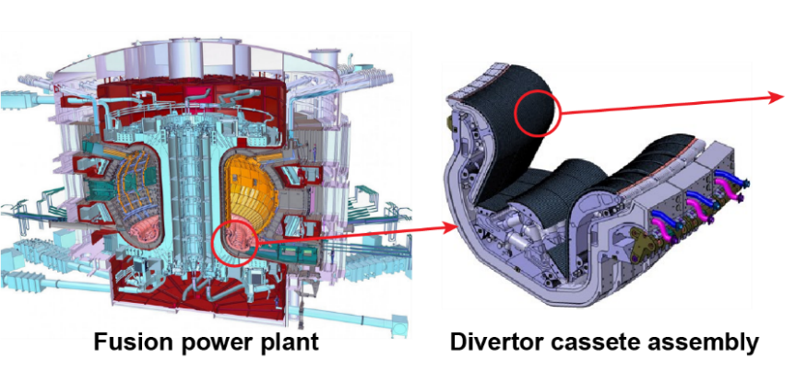
Minimum requirements for application:
- MSc in either material science, chemistry, or chemical engineering, mechanical engineering or similar,
- grade point average above 8 (exams and lab classes excluding the undergraduate thesis),
- age up to 28 years and fluent in spoken and written English.

Criteria for assessment of candidates:
- grade point average in all courses,
- awards or prizes received,
- participation in research work,
- scientific articles published,
- assessment of an interview with the candidate
The work will take place at the Department for Nanostructured Materials, at the Jožef Stefan Institute (https://nano.ijs.si/). A four-year PhD position is a fully-funded by the Slovenian Research Agency, starting in October 2021.

For additional information please contact:

Saša Novak (sasa.novak@ijs.si) or Aljaž Iveković (aljaz.ivekovic@ijs.si)

Deadline for application: 5th of August, 2021
Call for Tenders applicable to young researcher candidates with selected mentors in 2021 (July 14, 2021)

